Summary

Description:
Trail Life USA is a national organization which sponsors a Christian youth outdoor program for boys from kindergarten to age 18, and a coed program for boys and girls over age 18. The program focuses on Adventure, Character, and Leadership and is based in Biblical moral values and promotes a Christian Worldview.

Mission:
To guide generations of courageous young men to honor God, lead with integrity, serve others, and experience outdoor adventure

Program Overview: Woodland Trails Program (Kindergarten through 5th grade)
Patrol meetings- (1st & 2nd Tuesday of the month) from 7:00-8:15 PM
- Adult-led activities- for the purpose of developing character & skills
- Hands-on skills instruction & practice
- Fun
Hit-The-Trail Meeting- (3rd Tuesday or Saturday of the month) from 7:00-8:15 PM:
- When we get off campus and visit, see, develop and apply new skills Optional meetings- (4th Tuesday night of the month) from 7:00-8:15 PM:
- Worthy Life Award program – Focusing on spiritual development Yearly Events:
- 2-3 Parent/Child Camping trips, overnight trip(s), Banquet, Field Day and other
events
Service Project:
- Community oriented service opportunities such as The Big Sweep & Community Roots Day, as well as service projects for Calvary Baptist Church
Uniform:
Uniform will consist of a Trail Life USA, Troop 942 t-shirt, and Trail Life Polo shirt.

Advancement:
Boys work on advancement requirements called ‘Leaves’ in 7 categories called ‘Branches’ in each meeting or activity attended. Completion of the requirements for all 7 Branches earns the boy ‘Forest Award’. A boy has 2 years in each rank to complete requirements. Requirements for Rank Awards are prorated based on when a boy enters a prospective rank.

Cost:
$32 paid to Trail Life USA at online registration plus $50 Troop dues for the school year enrolled. Additional costs may be required for trips/events.

Welcome

We are excited that you are interested in joining Trail Life USA, Troop 942. Trail Life USA is a national faith-based character development organization for young men and as a charter member, it is considered a ministry of Calvary Baptist Church. Calvary has enjoyed a long and fruitful partnership with the Boy Scouts of America and considers the partnership with Trail Life an extension of a commitment to the discipleship and training of young men.

At Trail Life, we aim to provide a healthy, wholesome environment in which your son can learn skills for life – skills that not only enable him to excel today, but skills that help him to grow into a leader of others with the distinct attributes of purity, service, stewardship, and integrity.

While a member of Trail Life USA, Troop 942, your son will be able to enjoy learning new skills, participate in the adventure of camping, hiking, & cycling. He’ll learn about safety both at home and in the world and go on lots of adventures we call Hit-The-Trails. As he grows older, he will have an opportunity to participate in high-adventure activities as canoeing, fishing, backpacking, and even sailing among others. He’ll learn how to help an injured person or to save a life. And he’ll learn how to tie knots, lash spars and build camp gadgets. He will learn this within the context of established Biblical Values and a distinctly Christian Worldview, and he will have fun.

We at Trail Life Troop 942 are committed to seeing your son learn skills and experience adventure, as well as grow in character, and leadership.. To help him and you get started, we’ve provided this packet of information. This is not intended to be an exhaustive report on everything to expect, but it does cover a lot of details that will help you and your son make the adjustment to the Trail Life.

Also included in this packet are the necessary forms for registering your son with Trail Life, Troop 942. And there is even an opportunity, where you can volunteer to help as an adult leader.

If you have further questions, feel free to ask any of the adult leaders. Again, welcome to the Trail Life!

Description

An outreach ministry of Calvary Baptist Church, Trail Life USA, Troop 942 is a chartered member of a national organization which sponsors a Christian youth outdoor program for boys from kindergarten to age 18, and a coed program for boys and girls over age 18. The program focuses on Adventure, Character, and Leadership and is based in Biblical moral values and promotes a Christian Worldview.

Vision

The Vision Statement of Trail Life USA states: ‘we aim be the premier national character development organization for young men which produces Godly and responsible husbands, fathers, and citizens’. The vision for the program is to develop these traits through exposure to outdoor skills and activities.

Mission

The mission of Trail Life USA is to guide generations of courageous young men to honor God, lead with integrity, serve others, and experience outdoor adventure.

Membership

The program is open to all boys irrespective of race, religion, ethnicity, or national origin. Parents from all faiths are welcome to place their children in the program. While boys may come from every religious background, adult leaders in the program - from the National Board level to individual unit volunteers - will adhere to a standard statement of Christian faith and values.

When Do We Get Together?

Trail Life USA, Troop 942- Woodlands Trail Program meets from 7 to 8:15 on the 1st, 2nd, 3rd & 4th Tuesday night of the month, except on major holidays, days when public school is out because of inclement weather. All on-campus meetings begin with an assembly in Dining Room B of Calvary Baptist Church, B-Building, 5000 Country Club Road. Groups are then dismissed to go to patrol meetings based on age & grade. Patrol meetings are held in assigned rooms in A & B buildings at Calvary. An optional meeting on the 4th Monday night is available for boys who want to earn the Worthy Life Award which is the Faith Component of the Trail Life curriculum.

During our meetings, boys will work on advancement requirements in one or more of the 7 Branches of awards. They will meet in age graded groups. Each group will have separate activities based on age and ability. The Fox Patrols are for Kindergarten through 1st grade, Hawk Patrols are for 2nd and 3rd grade boys, and Mountain Lion Patrols are designed for grades 4 through 5.

Parent/Child camping trips are scheduled at least twice a year; see Trail Life Connect calendar for scheduled events. Changes will be announced at meetings and publicized in the meetings by Trail Life Connect. Trail Life Connect is the on-line activities calendar. This siet also manages troop membership and tracks boys progress toward rank advancement.

Woodlands Trail may meet at other times throughout the year, too. For example, we may schedule events on other days of the week, participate in a community service event, or schedule a work day or fund-raiser at Calvary Baptist Church.

Who Runs the Show?

The Woodlands Trail program (for Kindergarten through 5th grade) is an adult-run program. Adult leaders run the meetings and lead boys at events. Parents also work behind the scenes,

helping to ensure that meetings are well-planned and that outdoor events go well. The Senior Adult Leader is the Trail Ranger, Greg Wemple, who helps run all Woodland Trails activities.

Any Room for Adults?

The Woodlands Trail program is intended to engage parent and son together in activities for the purpose of building character, leadership, and skills in a fun and exciting atmosphere. The Woodlands Trail program needs approximately 15-20 adults who participate in various roles from Leaders to Committee members. Two-deep adult leadership is required for all interaction/ activities with the boys. There is always a need for more leaders. Adults are needed to lead skills training courses, to help with special events, to participate in outdoor activities, to drive vans and mini-buses, and in many other ways. We would welcome your interest and involvement.

Conduct Is Important

You will find no rules for behavior posted, but, Trail Life USA, Troop 942 does expect each boy to exhibit appropriate conduct by exhibiting a good attitude and spirit as well as the Character Traits of a Trailman in the Woodland Trails program (Purity, Service, Stewardship, and Integrity).

Just a few specifics:
Boys are expected to attend Woodland Trails meetings & events. Boys are expected to be in an appropriate uniform at each meeting.
Boys are expected to act appropriately in all Woodland Trails activities.
Such behavior as fighting or hitting, profanity or abusive language, or use of illegal substances will not be tolerated and may result in suspension of the privilege to participate in any or all activities
Boys are expected to show proper respect for leaders and their fellow Trailmen.

Reverence for God

Faith is an important part of the Woodland Trails Program. The religious views expressed during the meetings and outings will be consistent with those of Calvary Baptist Church and the Statement of Faith and Values which every Leader in Trail Life USA subscribes to:

“We believe that there is one Triune God – Father, Jesus Christ His one and only Son, and the Holy Spirit – Creator of the universe and eternally existent. We believe the Holy Scriptures (Old and New Testaments) to be the inspired and authoritative Word of God. We believe each person is created in His image for the purpose of communing with and worshipping God. We believe in the ministry of the Holy Spirit who enables us to live a Godly life. We believe that each individual is called to love the Lord their God with all their heart, mind, soul and strength; and to love their neighbors as themselves. We believe that each individual is called to live a life of purity, service, stewardship and integrity.”

Questions About Trail Life USA

What distinguishes the Trail Life USA from Boy Scouts?

Calvary Baptist Church has had a long history chartering both Pack 942 and Troop 942 with BSA and the program had much merit and has impacted countless numbers of boys positively for life. Many elements of the new program will operate similarly to Boy Scouts, but the main differences will be:
It will operate on principles and values that reflect a Christian worldview and all leadership will adhere to a consistent Statement of Christian Faith and Values.
It will promote and affirm Biblical moral standards as opposed to secular standards which promote moral neutrality.

What ages are admitted?

Trail Life USA has programs for youth from kindergarten to College. Woodlands Trail is designed for boys from Kindergarten through 5th grade. Navigators is designed for middle- school boys from 6th grade through 8th grade. Adventurers is designed for high school aged boys from 9th through 12th grade. The Guidon program is designed for youth after age 18 through age 25.

What distinguishes the operation of Trail Life USA in the various age groups?

- Adult Leaders conduct all meetings for the Woodlands Trail groups. It is designed to be a discipleship experience with a parent’s involvement, although boys may be involved without parental involvement. Camping for this age group is limited to 3-4 times per year.

In Navigators and Adventurers, boys, with some adult (other than a boy’s parents) leader involvement and supervision, conduct all meetings and events. Camping is an integral part of these Groups. Adventurer groups may plan additional separate trips that are
high-adventure and more rigorous.

- The events for boys in Woodlands Trail are family oriented. Adults plan, coordinate and lead most activities, which often lend themselves to full family participation.

Events for Navigators and Adventurers are run by the boys. Boys plan all activities (with adult guidance) and most activities do not involve full family participation.

- For the Woodlands Trail boys, advancement is done mainly in groups with the adult leaders determining the timing and the course of the boy’s advancement.

A boy in the Navigator ranks will have a big part in determining his advancement and a boy in the Adventurer program will have almost total control over his own advancement, which he will do mostly on an individual basis with the help of senior youth and many different adults.

How does advancement work?

For K-5th grade boys, ranks are by a 2-year grouping called a Patrol (Fox, Hawk, & Mtn. Lion). A boy has 2 years to complete his requirements along with his Worthy Life Award for that rank.
Requirements are prorated based on when a boy joins the Patrol. At the completion of each 2 year/grade rank, a boy is advanced to the next group.

For 6th-12th grade boys, rank advancement is based on the completion of requirements for skill training called Trail Badges (both required and elective), service time, leadership time, and the completion of a TroopMaster’s Conference and a Board of Review. All ranks and merit badges previously attained within Boy Scouts are transferable. Transferred ranks are assigned based on a BSA Transfer Module Worksheet and a transition to new rank requirements will be computed and assigned.

What can a boy expect in Trail Life USA, Troop 942?

Woodlands Trail program: Boys will be assigned to grade-level groups (Foxes, Hawks, and Mountain Lions), and will learn about Trail Skills, a proper respect for God’s creation, and engage in adult-led outdoor activities intended to reinforce the knowledge of it. The youth will advance in groups and will have many opportunities for individual recognition while having a lot of fun!

Navigators program: Older boys are placed in a “Patrol” of 6 to 10 boys (every effort is made to keep a boy with other boys he knows or is comfortable with). These patrols will be guided by experienced youth leaders (and supervised by trained adults) and are rotated regularly to facilitate camaraderie and learning between the boys. The primary focus for new Navigator members will be to learn basic camping, outdoor and survival skills. This helps to develop self - reliance and self-esteem. Youth are encouraged to participate in as many weekend campouts as possible since different skills are emphasized on each outing. Attending weekend campouts before long-term summer camp events is helpful because the youth then feels comfortable with his skills and abilities before going away for an extended time period. Experience has shown that boys who do not get involved with camping right away generally drop out within the first few months. Boys who camp regularly tend to advance quicker and stay with the program longer.

Adventurer program: High school aged young men group themselves into patrols of 6-10 boys. Patrols and leadership positions are rotated regularly to provide opportunities to build leadership skills in all members. The young men participate in advanced skills training, plan their own activities as well as give leadership over many Navigator program activities and skills training.
They progress through 3 major awards (Journey, Horizon, and Freedom awards) and control both the path and pace to achieve them.

Can a boy be active in sports as well as Trail Life USA?

Trail Life USA does not seek to compete with sports or other extracurricular activities and, in fact, experience has shown that successful youth are often those with a variety of activities and interests. We encourage all youth to be active in church, music, sports, school, other

organizations and other activities. We understand, however that a boy may not be able to participate in every planned event. The boy can learn to be a good steward of his time and energy with his involvements. As in any endeavor he will get back what he puts into it.

How can parents become involved with their son in Trail Life USA, Troop 942?

Adults are encouraged to participate in Troop 942. There is always a need for adults, as trained Registered Leaders to work directly with the boys, as Registered Adults who support and provide additional leadership roles, and as committee members who help facilitate Troop operations such as running fundraisers, making phone calls, coordinating outings, arranging transportation, or other tasks. There is no job too small and even the busiest person can help take the load off another person in some way. Adults also serve an important function as Skills Training Counselors, working with youth to complete the requirements for a skill. We would love to know skill resources available to the Troop in parents skills and abilities.

There is no requirement for parents to become involved with Troop 942 as a condition of joining, however, experience has shown that parents who are actively involved have youth who stay with the program, learn more, advance faster, and are better members than those whose parents are not involved.

In Summary. . . . . .

Trail Life USA, Troop 942 is a ministry, a program, and a group that is committed to helping boys develop to their fullest potential, learn values, learn leadership skills, build character, and be involved with a peer group which is wholesome, committed, active, and most importantly God-honoring. Left alone, boys from Kindergarten to age 25 will find plenty to do if there doesn’t seem to be anything presented to them. These involvements may or may not meet with your approval. We are committed to providing wholesome, God-honoring, & character-building activities.

We believe Traill Life USA is an excellent program and Troop 942 will continue a long heritage of discipling boys into worthy men. Encourage your son to become involved and consider becoming involved yourself.

What’s Going On?

Troop 942 will provide information on upcoming activities through:

Weekly Meetings: The most up-to-date information about trips and other events often is announced at meetings. It is not unusual for details of a trip to change at the last minute, so it is important for members to be at the meetings to obtain the latest information. Fliers about outings are distributed at Troop meetings a week or two before the event. Sign –ups will be available at that time as well.

Traillifeconnect: As part of your enrollment in the program, you will have access to, and receive information from, Traillifeconnect.com. This is an online Program Management System that controls all membership records, advancement, and the troop activities calendar. There is no access to these systems for boys 12 and under. The access will only be granted and managed by parents, who will remain responsible to manage the information from the Troop within their household.

The Troop Website: some information will be posted on the Troop’s public website www.traillife942.com as well as Trail Life USA, Troop 942 Facebook page.

Some Patrols may prepare a calendar for a specific rank. Ask your Trail Guide if one is available for your son’s patrol.

LIABILITY RELEASE FORM

(permission form, release, discharge and hold harmless agreement for specific activities)

Please copy this form, fill out (and sign in all places), and submit when specifically required by a specific trip or activity.

Trip To:

Leaving: Returning:

My name is (parent) and by this
instrument, I do hereby release, acquit, hold harmless and forever discharge Trail Life USA, Troop 942, & CALVARY BAPTIST CHURCH of Winston-Salem, Inc., its agents, servants, and employees, and all persons, natural or corporate, in privity with them or any of them, from any and all claims or causes of action of any kind whatsoever, including but not limited to actions, suits and/or claims for any bodily injuries, death or property damage which may be sustained by (student) while participating in any activity, or activities, including travel to and from such activities and any and all activities related to the Calvary Baptist Student Ministry & Trail Life USA, Troop 942, and/or resulting from the negligence or lack of care due or claimed to be due to the conduct of any agent, servant, or employee of Trail Life USA, Troop 942, and/ or CALVARY BAPTIST CHURCH.

By signing this agreement, I give my permission for (student) to receive medical attention in the event of an emergency.

Parent/Legal Guardian Signature Date

Medical Insurance Company Policy#

Policy issued under the name of

Resource Survey

At Calvary Outdoors, we invite you to share your skills and interests so that the best possible experience for the boys can be developed. In making this survey, the committee wishes to find ways you can enjoy using your talents to help train our youth. Life or Outdoor skills attained from Scouting, or other sources, are applicable even if not listed below.
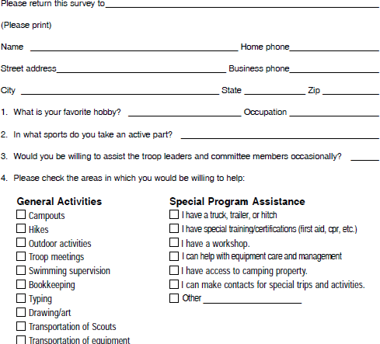

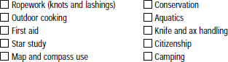
Skills

Activity Interest Areas
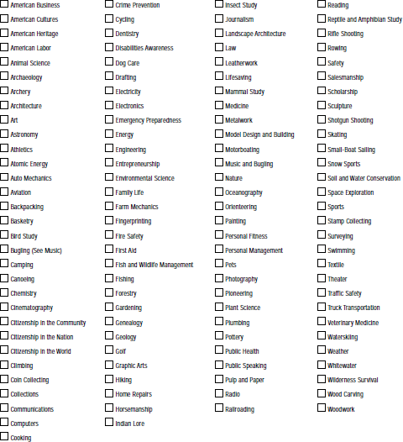

Advanced Skills/ Activities

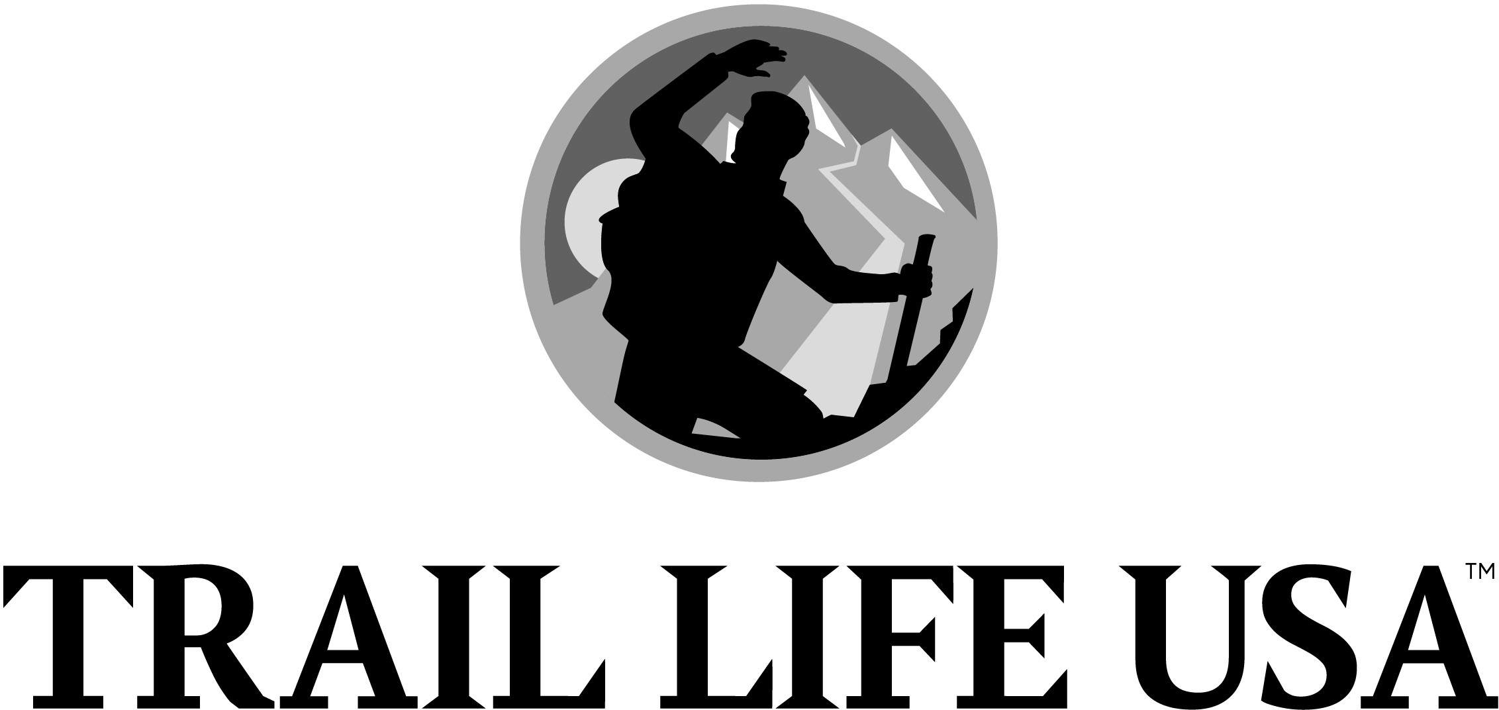

Thank you for visiting Troop 942. We would like a record of your visit so that we might be able to follow-up with you in the future. If you have any questions, go to www.traillife942.com/contact-us , please ask any of our registered leaders, write them in the space below, or email traillife@calvarynow.com

Visit Date:
Has your son been a member of a BSA sponsored program? Yes □/ No □ Boy Scouts □/ Cub Scouts □ Indicate highest rank achieved:
Contact Information:
Parent(s) Name:
Youth Name (last, first, MI): Age: Grade: Date of Birth: Address (#, Street, City, State, Zip:

Phone: (h)
(c)
e-mail:

Questions: (please list any questions you may have of Trail Life or the Troop)

Ranking Overview

reCruiT TrAilmAn
Joining rank

Able TrAilmAn
earn the recruit rank
Complete 4 navigators required Trail badges (see below) plus 3 elective badges Complete 15 hours of service for each year since joining navigators
Troop meeting attendance & participation requirements leader Conference and board of review
re Ady TrAilmAn
earn the Able Trailman rank
Complete all 9 navigators required Trail badges plus total of 5 elective badges Complete 15 hours of service for each year since joining navigators
Troop meeting attendance & participation requirements. Hold a leadership position or fulfill a leadership requirement Faith building activity option
leader Conference and board of review
A
Journey AwArd
Joining Award

Horizon AwArd
earn the Journey Award
Have earned all 15 required Trail badges (see below) plus a total of 10 electives Complete 20 hours of service for each year since joining Adventurers
Hold a leadership position or fulfill a leadership requirements Troop meeting attendance & participation requirements leader Conference and board of review

Freedom AwArd
earn the Horizon Award
Complete the Freedom experiences for your major and 2 minors Troop meeting attendance & participation requirements Servant leadership Project
Faith building activity option
leader Conference and Freedom board of review

Navigators Trail Badges Adventurers Trail Badges

6–8th Grade

CAMp ING
OUTDOOR COOkING
ROp EwORk wOODS TOOLS
AqUATICS
FIRE RANGER OUR FLAG
TRAIL Sk ILLS FIRST AID

+
ToTAl 15
9–12th Grade

EMERGENCY pREp.
FAMILY MAN
pERSONAL RESOURCES CITIZENSHIp
OUTDOOR LIFE FITNESS BADGE

A Note About Transferring an Eagle Award
////////////
ADVENTURERS
9-12th Grade
NAVIGATORS
6-8th Grade
N
FIRST CLASS
TENDER- FOOT
EAGLE
LIFE
STAR
SECOND CLASS
SCOUT
READY TRAILMAN
ABLE TRAILMAN
RECRUIT
FREEDOM
HORIZON
JOURNEY
pROGRAM STRUCTURE // EFFECTIvE 9/2013–12/2013
/
Attaining the BSA’s Eagle Award is a significant accomplishment in a young man’s life. Trail Life USA developed our Horizon Award requirements to closely parallel the merit badge requirements of the Eagle Scout Award and to honor the historic legacy of this important achievement.

As an additional challenge to all Trailmen who attain their Horizon Award, we have added a unique Freedom Award that is earned in a particular

//////////////////////

“Major,” similar to how one might earn a degree in a specialized area of study. It requires participation in unique “Freedom Experiences” as part of our “Majors and Minors” program. These Majors and Minors add value to the Freedom Award by encouraging hands-on real-life experiences that build a habit of active participation and citizenry and prepare our young men for college and life after high school.

TRAIL
I

;,
\..
...
•'
\ ,:V-

LIFE USA

TROOP

Led by Troopmaster
COLLEGE-AGE
-------------- ,

{Knowled&<J
K-5'" Grade
WOODLANDS TRAIL
Led by Ranger
(Undersrantfin5}
6"'-8'" Grade

NAVIGATORS
Led by Trallmaster
(Wtsdom}
9"'--12•Grade

ADVENTURERS
Led by Advisor
{Life}
18-25 Years

GUIDON
Led by Advsi ors

Lewis
Fox > > HaWk > > Mouuonntain
Ranks Awards Coed Members
> > > > Recruit > > Able > > Ready > > > > > Journey > > Hortzon > > PREEDOM
"·"-
TtaUman Tl'allman 1tallman TN,,,.. ....
N:0Nl6

(Spiritual Growth)
K-5'"Grade
WORTHY LIFE PROGRAM
(Spiritual GrowrhJ 6•-12'" Grade II DELTA PROGRAM

Manhood Journey > > > > > Band of Brothers > > > Vanguard 6"'- 8 • Grade 9"-12'" Grade ll"-12'" Grade

