https://forms.gle/bnHk2AvbT5KuwFud8

Trailblazer Trip Plan
PATROL NAME
TRIP NAME
WHEN
WHERE
Trail Blazer Youth
Trail Blazer Adult
RESEARCH AND DESCRIBE THE TRIP
NATURAL COMMUNITY
HISTORICAL INFO
SPECIAL PREPARATION
WEEKEND ACTIVITY PLAN
Friday night Activity
Saturday Activity
Sunday Activity
TROOP ANNOUNCEMENT
MAP PIN
BACKPACKING = TWO TRIPS
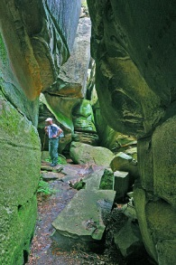
May – Spring
The Channels State Forest, 4250 Hayters Gap Road, Saltville, VA 24370 36.868220053114555, -81.94774074510953 (2 hour 30 minute drive) http://thegirlandglobe.com/the-great-channels-of-virginia/ Camp: Brumley cove Baptist camp - 21551 Brumley Gap Rd Abingdon, Virginia, VA 24210 (276) 944-4673 Mickey & Robin Johnson
https://www.facebook.com/brumleycove/
http://www.dof.virginia.gov/infopubs/_state-forests/CHSF-2013-05_pub.pdf
http://www.dcr.virginia.gov/natural-heritage/natural-area-preserves/thechannels
Note: A pretty neat place kinda an east coast version of a slot canyon that you might see at Buckskin Gulch in Utah. This will be unlike anything Troop 942 has done before!

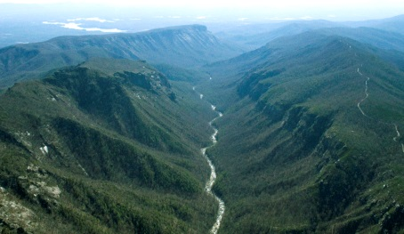
May – June
Linville Gorge Wilderness “The Grand Canyon of North Carolina”, Cherokee Indians call this area Ee-see-oh, which means "river of many cliffs" Old Highway 105 Marion NC (2 hr 45 minutes) Is a really special place for the troop to Back Pack. Must get a permit call Grandfather Ranger District, 828-652-2144 on April 2 at 8:00 AM Sharp!, Groups are limited to 10 – 10 AM Information cabin old 105 right past Linville falls parking lot before Wiseman’s view 15 more. If lots of interest the troop would need to split up in groups of 10 possibly.
Camp: Permit Back Packing – OR campground https://www.recreation.gov/camping/linville-falls-campground-blue-ridge-pkwy/r/campgroundDetails.do?contractCode=NRSO&parkId=74042
Hike: Linville Gorge Trail - Pine Gap Old N C Hwy 105, Newland, NC 28657 to Pinch in 1600 Pisgah Highway Pisgah National Forest, NC, Possibly Shortoff mountain?? 8 to 13 miles
https://www.fs.usda.gov/recarea/nfsnc/null/recarea/?recid=48974&actid=37 http://www.appalachianhighcountrytrails.com/linville_gorge.html
WEST RIM - Pinch In trail Old NC Hwy 105, Newland, NC 28657 (2 hour 15 min drive)
HIKE: Pinch In trail Old NC Hwy 105, Newland, NC 28657 (2 hour 15 min drive) to Linville Gorge Trail – Conley Cove Trail – Rock Jock Trail 8 to 13 miles - http://www.zacharyrobbins.net/pinch-in-rock-jock-linville-gorge-wilderness-nc/ http://www.linvillegorge.net/
EAST RIM - Wolfpit Trailhead 35.82416, -81.88940 and end at Table Rock 35.88669,-81.99448. Camped at Saddle Camp night one and Pine Needle Camp on night two
https://www.alltrails.com/trail/us/north-carolina/mountain-to-sea-trail-the-chimneys-and-table-rock-mountain
https://caltopo.com/m/2Q2R

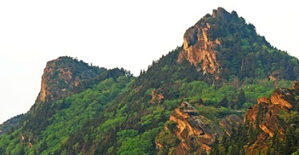
April, May or June 1 Wolverine, 1 buffalo
Back packing at Grandfather Mountain
Camping start at Daniel Boone Backpack Campsite where reservations can be made (2 hour drive)
Grandfather Mountain State Park http://www.ncparks.gov/grandfather-mountain-state-park/camping
Comments: Challenging Hiking and the amazing views of Grandfather Mountain. This could be cold weather camp or make it a spring summer trip. This is very popular place to it needs to planned in advance pretty well

June
Panthertown Valley Backpacking, “the Yosemite of the East” Sapphire, NC 28774 (3 hrs 30 minutes) in the Nantahala National Forest designated at Blue Ridge National Heritage Area https://www.hikewnc.info/trailheads/panthertown-valley/ . Pretty neat place.

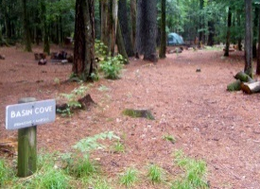
December Basin Cove EASY Backpacking
Doughton Park on Blue Ridge parkway Grassy Gap Fire Road Mcgrady NC (1 hour 30 minute drive)
http://www.hikingupward.com/NCSP/BasinCreek/ https://www.nps.gov/blri/planyourvisit/doughton-park-trails.htm Permits Bluffs District Office 828-348-3487 – in season permit 336-372-8877 (must have car info and license plate) 36.391361, -81.169083 – Parking lot
36.375221, -81.144745
Comments: troop 942’s back yard with various trail options. Should be an easy back packing trip without a lot of traveling. IF Trail men want something challenge there is the Bluff Ridge Primitive Trail a very hard vertical trail goes all the way to the blue ridge parkway.
OR Doughton recreation area has many hikes that are challenged. Basin Cove camp is good starting off point. A 13 mile loop that is good shakedown hike is Grassy Gap Fire Road, Bluff Ridge, Bluff Mountain and Cedar Ridge Trail Loop https://www.alltrails.com/trail/us/north-carolina/grassy-gap-fire-road-bluff-ridge-bluff-mountain-and-cedar-ridge-trail-loop--2

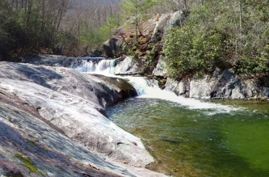
August
Summer Back packing
Upper Pisgah National Forest Wilson Creek area
http://www.hikewnc.info/trails/wilson-creek/ Start at Huntfish Falls Hiking Area Pineola Rd, Collettsville, NC 28611 (2 hour 20 minute drive) Comments: The Wilson creek area is a beautiful place and a very popular back packing for ASU students. This is different hiking in a river gorge compared to most of the AT Mountain Hiking the troop has done. I did it a few times in College.

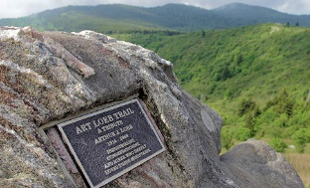
August Summer trip
Lower Pisgah National Forest camping and Waterfall country Absolutely tons of outdoors opportunities from Tubing trip, Sliding rock swimming area, Waterfalls, the Cradle of the Forest, Art Loeb Trail, Fish hatchery, the list goes on. Hike: Shinning rock Wilderness - Black Balsam Knob trailhead - Art Loeb Trail from Black Balsam Road (MP 420 on the Blue Ridge Parkway). PRIMITIVE CAMP: across from Art Load Trail Head on Black Balsam Road 35.320575, -82.876219 (3 hr) CAR CAMP: Davidson River camp ground OR Cove Creek Group Campground (3 hour) http://www.recreation.gov/camping/davidsonriver/r/campgroundDetails.do?contractCode=NRSO&parkId=70204 visit Skinny Dip falls (35.322314, -82.827959)Or Back pack thru-hike on Art Loeb trail. Starting on Section 3: Black Balsam Knob to Deep Gap: 6.8 miles ending Section 4: Deep Gap to Daniel Boone Boy Scout Camp: 3.8 miles (3647 Little East Fork Rd, Canton, NC) Comments: The Art Loeb Trail is one of the most popular trails in Western NC. It has been called the Mini AT. Similar to Mt Rogers trip. Also nearby Art Loeb is the graveyard fields on the Parkway
June
Back Pack thru hiking in one of the most well known scenic sections of Appalachian Trail to Max Patch meadows. A Top 10 Appalachian trail scenic section. Start on AT below Hot Springs NC – Maybe Garenflo Gap or Bluff Mountain Road Bluff hot springs NC 35°51'12.8"N 82°53'46.4"W 35.853549, -82.896211 (3 hour drive) Pick up at Max Patch meadows, Max Patch Rd
https://www.youtube.com/watch?v=yjrNWXTxskE&feature=youtu.be – Friday night camp - Silvermine Group Campground 828-682-6146, Rocky Bluff Recreation Area Hot springs

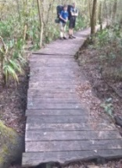
January or February Winter
Coastal forest camping = Croatan National Forest - ( 4 hr drive) http://www.fs.usda.gov/recarea/nfsnc/recreation/camping-cabins/recarea/?recid=48466&actid=34 Winter or early fall Hike & Back pack Camp on Neusiok Trail http://www.c2wlc.club/NT.html Comments: The Neusiok trail will be something different than most trailman would be familiar with being a coastal forest. Friday 2945 NC-101, Havelock, NC 28532, 34.86965093738827, -76.8062341837307 Sleep at Dogwood Camp Saturday - Camp on beach at Pinecliff recreation area on the Nuese river 34.938690, -76.822017.

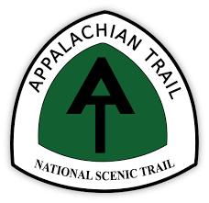
Mt. Rodgers – Appalachian Trail back packing Camp on AT and Hike to Mt Rogers classic trip OR
Scales camp – Crest Trail (Pine Mtn) – Wilburn Ridge –AT a new twist on the standa rd Mt Rogers trip OR
Grassy Ridge Bald & Roan Mtn Shelter at Carvers Gap on Hwy 261. One of the top ten scenic views on the AT. (Roan High Knob Trail Parking Lot Bakersville, NC or Carvers gap parking lot Fork Mountain-Little Rock Creek, NC to Yellow Mountain Gap Trailhead Roaring Creek Rd Newland, NC or 760 Hampton Creek Rd, Roan Mountain, TN 37687)

May-June 1 wolverine
The Overmountain Victory Trail (4 miles)/Appalachian Trail to Carvers Gap(5 miles). 2 hour 45 minute drive
Back pack hike over Yellow Mountain Gap and connecting to the Appalachian Trail. Camp at Overmountain Shelter which is a huge red barn that is maintained by the park service. This trail is the trail that the Revolutionary Volunteer Army used to cross Roan Mountain while on their way to Kings Mountain to fight the British. These men were called the Overmountain Men. http://www.appalachianhighcountrytrails.com/overmountain_victory_trail.html
Camp: Overmountain shelter Friday night, Grassy Ridge Saturday night. Directions: Drop off at Roaring Creek Road Newland NC. From Boone; Take NC 105 S, turn right at NC 183, turn left at NC 194, turn left at US-19E, turn right to stay on US-19E, turn right on Roaring Creek Rd, follow road all the way to the end, trailhead is at the end of the stone road. Pick up at Carvers Gap Fork Mountain-Little Rock Creek, NC 28705. Probably the most scenic Back packing trip the troop can take. Amazing views!

January
Uhwarrie National Forest https://www.fs.usda.gov/recarea/nfsnc/recarea/?recid=48934 1 hour and 18 minutes
Camp: Yates Place Campground 700 Dusty Level Rd, Troy, NC 27371 https://www.fs.usda.gov/recarea/nfsnc/recreation/camping-cabins/recarea/?recid=48948&actid=29 (options BACKPACKING - Birkwood Wilderness, car camp West Morris Mountain campground, Arrowhead campground (Badin Lake area) )
Hike: 10 miles = Yates Place Trail to Uwharrie National Trail (white) ½ mile, Dutchman’s Creek Trail (yellow) 5.5 miles, Left back to the Uwharrie National Trail (white) 2.75 miles, Right Dutchman’s Creek Trail (yellow) ½ mile, Yates Place Trail (options Birkwood Wilderness) http://landtrustcnc.org/2014/dutchmans-creek-trail/ Other Uhwarrie audio tour(http://landtrustcnc.org/ut-audio-tour/):

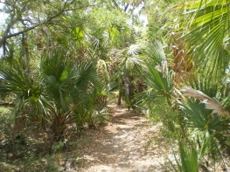
January or February Winter
Coastal forest camping = Palmetto trail Awendaw passage - Francis Marion National Forest - (4.5 hr drive) Halfway Creek Primitive Camping Huger, SC to Buck Hall Recreation Area Buckhalll Landing Rd, McClellanville, SC (11 miles). NC has the mountains to sea trail and SC has the Palmetto trail. The Awendaw is the end of the Palmetto ending at an intercostal waterway at Bulls bay.

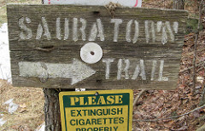
March - April
Sauratown Trail - Navigator/Adventurer “Meet up in the Middle”
Friday Night Navigators camp at Pilot mtn Adventurers camp at Hanging Rock Saturday
Both Hike NC Mountains to Sea trail http://www.sauratowntrails.org/ (10 miles each way) http://sauratowntrails.org/trailsection.html
camp at http://www.mtntrailstables.com/ 1630 Merridon Drive Pinnacle, NC 336-351-5654
Sauratown Trail Hanging Rock to Sauratown Mountain area (Mountains to Sea Section 7)
https://mountainstoseatrail.org/segment/7/ http://www.sauratowntrails.org/trailsection.html
Go Moores Wall Loop Trail RIGHT “Counter clockwise” to Right onto Tory’s Den Trail LEFT on Mickey road, LEFT on Moore Springs Road, LEFT on Hwy 66, Past old service station back into woods, LEFT on to Rock House Road, RIGHT back into woods, LEFT onto Rock House briefly, the RIGHT onto Thore Road, RIGHT onto Flat Rock short distance, the Left back into the woods end at Mountain Top Youth Camp Lodge 1460 Mackay Lane Pinnacle, NC https://mountaintopyouthcamp.org/ or take short spur trail to Mountain Trail Stables 1630 Merridon Drive Pinnacle, NC 336-351-5654 http://mtntrailstables.com/

CANOEING = TWO TRIPS
February- March – April 1 ml, 1 wolverine, 1 cobra
Merchants Millpond State Park, 176 Mill Pond Rd, Gatesville, NC 27938 (4 hours drive) . Canoe With Alligators! = Canoe the Gatesville Paddle Trail 5.7 miles Other option = Bike the Lassiter Trail & Fire Road 6+ miles. https://www.ncparks.gov/merchants-millpond-state-park http://www.ncpedia.org/merchants-millpond-state-park

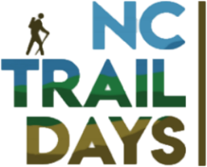
First Weekend in June
Yadkin river – put-in at Ronda get out a Crater park. NC Trails days in Elkin, NC, Camp in downtown Elkin at Crater park

Ton’s of stuff happening all day.. Should be a great time!! GREAT way to end the Trail Life year!

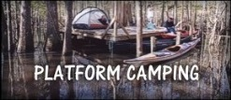
October or November Platform camping http://www.roanokeriverpartners.org/pf-home.aspx
http://www.townofwilliamston.com/departments/recreation_department/river_landing.php 744 River Road Williamston NC (3 hour and half drive) Comments: Awesome Canoeing through the Roanoke River National Wildlife Refuge through miles of an unbroken bottomland hardwood forest and a cypress-tupelo swamp ending at the Abermarle sound. Some of the bald cypress trees are 800 years old! It is wild & isolated river a kind of Amazon of NC . Unlike anywhere else on the east coast of the US. Trail men would sleep on river platforms along the way. Point Man Darrell Norris. cape Notes: Trail men need to purchase large dry bags = Walmart http://video.unctv.org/video/3000691771/ Must reserve by prior August
Friday – Williamston River landing platform – Saturday – Beaver Lodge/Beaver Tail – Sunday - Jamesville NC wildlife boat landing OR Camp at Spruill Farm 767 Spruill Loop Rd, NC State Rd 1318 Roper, North Carolina 1 910-599-5640c on Albemarle sound & do paddle trip on Conaby Creek East of Plymouth. Roanoke Outdoor Adventures Call 252-809-9488 or email: roanokeoutdooradventures@embarqmail.com
OTHER EASTERN NC PLATFORM options:
Bennett's Creek paddle trail - Platform Merchant Mill Pond
Catherine & Warwick Creeks paddle trail - Platform Holladay Island – Friday night - Warwick Baptist Church 4314 Virginia Rd, Hobbsville, NC 27946 warwickbaptistnc.com (252) 221-4375 Saturday - Start at 380 Cannons Ferry Rd Tyner, NC 27980 36.313553, -76.656963 to Platforms at Holladay.
Pembroke Creek, Queen Anne Creek, Trestle House, Cape Colony paddle trails – Platform John’s Island – Friday Ryan's Grove Baptist Church 116 Ryans Grove Rd, Edenton, NC 27932 (252) 482-8539 Saturday Wildcat Bridge, Edenton, NC 27932 36.088267, -76.641159
Perquimans River, Goodwin, Raccoon, Mill & Suttons Creeks paddle trails – Platforms near Hertford – Friday Chappell Hill Baptist Church Belvidere, NC 27944 (252) 297-2161 Saturday Beech Springs Rd Belvidere North Carolina 27944 36.239875, -76.550892
Pasquotank River & Sawyers Creek paddle trails – Platforms Goat Island Double and Northside Double – Friday Newland United Methodist Church 1686 Morgans Corner Rd, Elizabeth City, NC 27909 newlandumc.org (714) 394-0717 Saturday Morgans corner Road bridge Newland North Carolina 36.422158, -76.347499
Moyock Creek & Northwest River paddle trails – Platform Northwest river – Friday Moyock Baptist Church 123 Oak St, Moyock, NC 27958 moyockbaptist.org (252) 435-6230 Saturday Shingle Landing Boating Access 129 Creekside Dr, Moyock, NC 27958 Moyock, North Carolina , Fellowship Baptist Church 871 Tulls Creek Rd, Moyock, NC 27958 (252) 435-6453
Indiantown Creek paddle trail – Friday First Baptist Church 300 W Main St, Elizabeth City, NC 27909 (252) 338-3904 Saturday – S Indiantown Road Bridge Black Swamp North Carolina 36.349642, -76.073215 to North River Campground 256 Garrington Island Rd Shawboro, NC 27973
Conaby Creek paddle trail – Platform Royal Fern – Friday - First Baptist Church 309 Washington St, Plymouth, NC 27962 firstbaptistplymouth.org (252) 793-5026 Saturday - Plymouth Kayak/Canoe Launch Plymouth, NC 27962

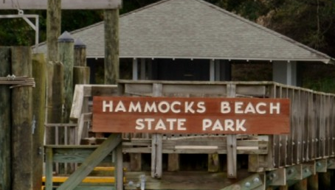
October or Maybe June? 1 ml
Beach camping 1, Fishing & Sea Kayaking
Hammocks Beach State park 1572 Hammocks Beach, (Bear Island) Swansboro, NC 28584 (4 hour drive)
http://www.ncparks.gov/hammocks-beach-state-park
Comments: A different look on a fishing trip but also nice place.

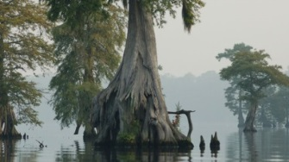
May
Canoeing the Great Dismal Swamp. $$
Dismal Swamp State Park 2294 US-17, South Mills, NC 27976 (252) 771-6593 (4 and ½ hour drive)
http://www.ncparks.gov/dismal-swamp-state-park/events-and-programs/paddle-border
Paddle for the border event May 6th 2017 from South Hill NC to Cheasapeke Va – End of April, things to visit Museum of the Albemarle, United States Coast Guard Complex, Comments: This is such a fun event or if we didn’t want to be a part of the event you could do this separately canoes can be rented in VA or NC. Camp at South Mills Church Roy McLeod 252-202-4456 (Cell phone) 252-771-5644 (SMCC) uthevangelist@gmail.com
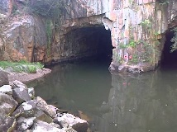
Falls Reservoir – the Narrows Dam tunnels –Lots of Dispersed canoe-in camping sites on Uwharrie – National Forest side or drive to Deep Water Trail Camp 35.404865037951254, -80.08524629147058 . Below reservoir on the other side is Morrow Mtn State park which has a Group Camp. https://www.youtube.com/watch?v=0xZXXU5Vbio

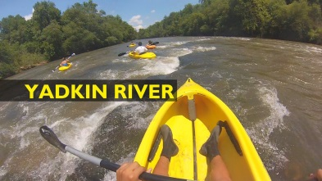
May-June
Yadkin River Float Trip
Camp: Ken Putman’s River Access (Ken’s Bike Shop) Rockford to Siloam (Ken Putnam’s take out 4169 Scott Road East Bend kensbikeshop1@gmail.com) Saturday Float to Donnaha Access for Lunch (2 hr) Donnaha to Old 421 park (3.5 hr) (Accesses - RONDA N 36º12.95’ W 80º56.25’ & 6.8 , CRATER PARK N 36º14.50’ W 80º50.84’ & 10.7 , BURCH STATION N 36°16'34.0" W 80°46'02.4’ & 4.7 , YADKIN/SHORE N 36º16.18’ W 80º43.23’ & 5 camping , SHOALS N 36º15.45’ W 80º31.05’ & 6.9 Camping , DONNAHA N 36º12.95’ W 80º26.02’ & 6.6 https://www.yadkinriverkeeper.org/yadkin-river-access
Other: Could do the Kayak Trail Badge work
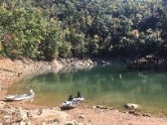
Fontana lake – paddle in site #87 Jerry Hollow – near Smokie mtn national park.

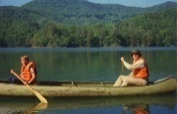
Lake Santeetlah - Cheoah Point Campground (4 hrs), 1373 Thunderbird Mountain Rd, Robbinsville, NC 28771 (828) 479-6431 – Sunday do a quick hike at Joyce Kilmer Memorial Forest – Giant old growth trees.
New River State Park - Canoe in campgrounds – Wagoner, Prather's Creek, Alleghany - Visit Phipps country store 2425 Silas Creek Rd, Lansing, NC 28643 Rita Scott 336-384-2382, Sunset Overlook, Mount Jefferson State Natural Area 1384-1944, Mt Jefferson St Park Rd, West Jefferson, NC 28694 8:28 PM

Lake James state park – Long Arm Paddle in Campground
Pilot Mountain State – Yadkin river - Ivy Bluff section paddle in campsites
Hanging rock State park – Various accesses to the dan river – camp on river at Lewis & Maxine Wood’s Camp (336) 593-8648 1157 Wood Rd Danbury, NC 27016
NEW RIVER TRAIL STATE PARK in VA - Double Shoals Campground canoe in campground.

SERVICE CAMPING = ONE TRIP
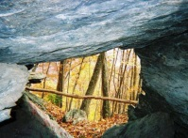
December or Mid April or May 2017?
Caving at DEVIL'S DEN NATURE PRESERVE 80 Cemetery Rd Fancy Gap, VA Dianne Martin (276) 728-4273 dianesm@yahoo.com
Camp at Fancy Gap / Blue Ridge Parkway KOA 47 Fox Trl Lp, Fancy Gap, VA 24328 (one hour drive) https://www.youtube.com/watch?v=t2xrlwdVL_U
https://www.myswva.org/outdoors-venue/devils-den-nature-preserve Comments: Another laid back trip & SERVICE PROJECT!

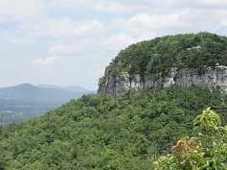
April
Service project / camping
Camping at Pilot mtn state park or Hanging rock state park or others… April 22nd is EARTH DAY and both parks have private organizations that do park service projects on or around earth day.http://www.ncfsp.org/Projects . OR do some service project work at the Devils Den Preserve. They could use the help!

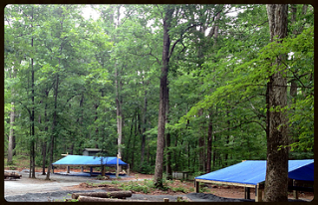
December, September, or Spring
Hammock camping in style! & Service hours
Camp Caraway Hammock outpost http://www.caraway.org/#!camp/c1jh6 4756 Caraway Mountain Road Sophia, NC 27350 (1 hour drive) Comments: A possibility of working a partnership with Camp Caraway and troop 942 to develop their Slick Rock trail and primitive sites by building tent platforms. Mark Moore Director 919-862-4865 336-521-9207 http://www.rockinghamcc.edu/publications/trails

September every year
Sauratown Trail SERVICE PROJECT– Bushwacking trail clearing of Sauratown trail for the Make-A-Wish Trailblaze Challenge – October each year
Friday Night Camp at camp at http://www.mtntrailstables.com/ 1630 Merridon Drive Pinnacle, NC 336-351-5654
NC Mountains to Sea trail http://www.sauratowntrails.org/ (10 miles each way) http://sauratowntrails.org/trailsection.html

SHOOTING SPORTS = ONE CAMPING TRIP
November
Shooting sports $$ Trail badge weekend
Camp at Jomeokee park Pinnacle - Shoot at Jomeokee park
OR
Camp at Millstone 4-H Camp, 1040 Mallard Dr, Ellerbe, NC 28338 (1 hr 30 min) nc4hcamps.org (910) 652-5905 - Shoot at Lentz Hunter Education Complex
Notes: Amo Cost, We need to have range safety officers. To stay at Millstone it is $10.00 per person per night.

MOUNTAIN CAMPING TRIPS
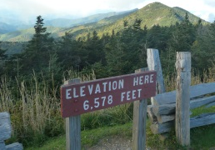
September
Black Mountain camping trip hike up to Mt Mitchell (2 hour and half drive)
Black Mountain and Briar Bottom campgrounds 35.751149, -82.220084 http://cfaia.org/black-mountain-briar-bottom-campgrounds-in-north-carolina/
Or Carolina Hemlocks campground 6000 Hwy 80S, Burnsville, NC 28714
Mountains to Sea Hike 5.5 mile UP from Black Mountain and Briar Bottom campground up to the top of Mount Mitchell State Park. This hike qualifies as a SB6K (South Beyond 6000 Challenge peak) ascending 3600 feet in 5.5 miles. A hiker can granted member to the South Beyond 6000 club if the climb 40 peaks over 6000 ft in TN and NC that the Carolina Mountain Club designates on their website https://www.carolinamountainclub.org/
Comments: I understand this Cradle of the Forest campground is a nice campground and great because of it being so close to Mt. Mitchell. This could be a nice change on what the troop has down before with Mt. Mitchell. http://www.hikewnc.info/besthikes/appalachian-ranger-district/mount-mitchell

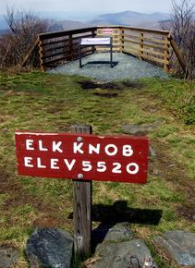
September – Fall or Summer
Elk Knob State Park 5564 Meat Camp Road Todd, NC (1 hr 45 min)
Hike: Summit Trail 1.9 Mile & many other hikes
Notes: relatively 2003 new park in Troop 942’s backyard. Might be neat to try when the leaves change. This park can be a base camp to try out Three Top Mountain trail near by (Poplar Trail road Creston, NC 28615) or the SNAKE MOUNTAIN TRAIL. These are hard trails to some 5000 feet elevation. https://www.hikingupward.com/NCSP/ThreeTopMountain/ September the park has a heritage day festival and Summer time there is many concerts in the town of Todd. Easy trip and close to home. https://www.ncparks.gov/elk-knob-state-park https://www.hikewnc.info/trailheads/elk-knob-state-park/ http://toddnc.org/events-activities/summer-concerts/
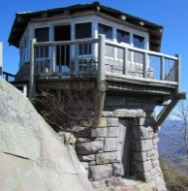
October 1 buffalo
Mt. Cammerer Great Smoky Mountains National Park,
Camp: Cosby Campground - 127 Cosby Entrance Rd, Cosby, TN 37722 (423) 487-2683 (3 hr 30 min drive) – Optional back packing.
Hike: Low Gap Trail/Appalachian Trail 11 miles out to the 4928 mountain’s stone fire tower and back. Strenuous trail
Comments: This trail is highly rated in the smokies and one website rates this trail as a top 10 hike on the east coast

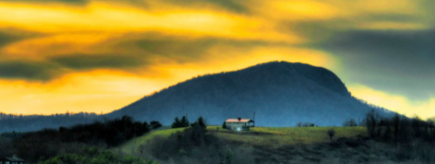 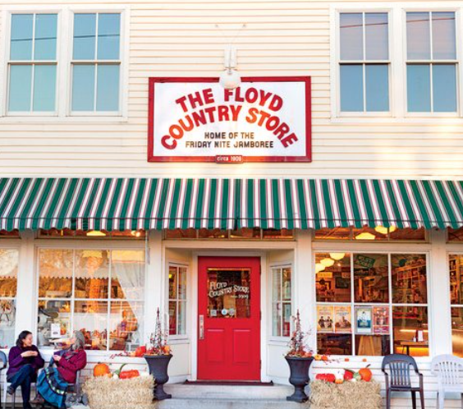 Buffalo Mountain hiking, Floyd country Store music, Airsoft, Fun Laid Back weekend in May possibly. Maybe pick and instrument and play something….. Work on a metal craft with https://wanderlustfabricationdesign.com/
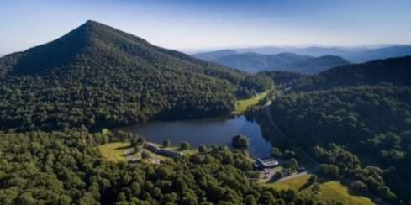
November or Spring
Blue Ridge parkway hiking
Camp: PEAKS OF OTTER CAMPGROUND 10454 Peaks Road Bedford VA 24523 (2 hour 45 minute drive)
Hike: Hike 3 mountains = Sharp Top Trail –1.5 mile (3875 ft) Flat Top Trail – 4.4 mile (4001 ft) Harkening Hill 3.3 mile (3,372 feet) Comments: Peak of Otters is in a valley surrounded by three mountains with hiking trails to each. It is one of most popular hiking locations on the Blue Ridge Parkway. The town of Bedford is home to the National D-Day memorial. http://www.dday.org/. The town of Bedford had the highest percentage of men killed in the initial landings. Bedford was one the towns featuring in Ken Burns World War II documentary “The War” http://www.pbs.org/thewar/ Also Liberty University is close by which could be neat to visit when something is going on…..

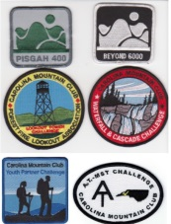
Spring or June The Carolina Mountain Club is one the oldest well known hiking clubs on the east coast. They have couple of very cool mountain hiking challenges that the troop could plan a camping trip around. Upon completion of a challenge a patch is awarded. South Beyond 6000 (SB6K) - hiking 40 selected southeastern 6,000 foot peaks, Lookout Tower Challenge (LTC) - hiking to 24 fire towers in WNC, Pisgah 400 (P400) - hiking all 400 miles of trails in the Pisgah Ranger District, Waterfall & Cascade 100 (WC100) - hiking to 100 of WNC's most spectacular waterfalls, A.T.-MST Challenge - hiking the 92 miles of the AT and the 135 miles of the MST the CMC maintains, Youth Partner Challenge - established to introduce young people under 18 to hiking and the outdoors.

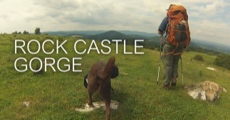
October
Blue ridge parkway camping
Rocky Knob Campground 1670 Blue Ridge Pkwy, Floyd, VA 24091 (hour 45 drive)
http://www.reserveamerica.com/camping/rocky-knob-cg/r/campgroundDetails.do?contractCode=NRSO&parkId=72350
Hike Rock Castle Gorge trail https://www.nps.gov/blri/planyourvisit/rocky-knob-trails.htm visitor center 540-745-9662 campground 540-745-9664) Comments: Great place in troop 942’s backyard and the Rock Castle gorge is just another unique trail that I have heard others talk about. Stay when the leave changes! 8 miles from the Floyds Country Store which awesome place to visit on Friday nights. Good snacks and music!
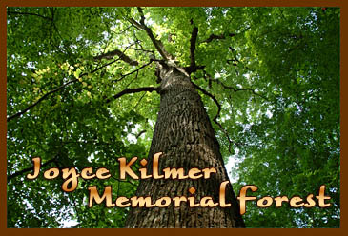
July or August trip
Nantahala National Forest camping & “Giant Sequoia trees” of the east coast = Joyce Kilmer Memorial Forest http://www.grahamcountytravel.com/brochures/JoyceKilmer/index.html
Camp: Horse Cove Campground Joyce Kilmer Rd, Tapoco, NC 28771 fs.usda.gov (828) 479-6431 (4 hour drive) http://www.fs.usda.gov/recarea/nfsnc/recarea/?recid=48924 OR RATTLER FORD GROUP CAMPGROUND HWY 1134 ROBBINSVILLE NC
Comments: This old growth forest is really amazing. The Tulip poplar and Hemlock trees are gigantic. Since this is such a long drive probably also needs to be a summer trip. http://joycekilmerslickrock.org/
August or Summer
Mt Leconte Hike Great Smoky Mountains National Park
ELKMONT CAMPGROUND, TN 434 Elkmont Road Gatlinburg TN ( 4 hours)
Alum Cave Trail to Mt Leconte Peak 5.5 miles one way http://www.hikinginthesmokys.com/lecontealum.htm http://www.highonleconte.com/daily-posts Notes: Hiking to Mt Leconte gives the best feel for what the Smoky Mountains are all about. A memory maker and bucket list trip. Car camping trip. Back Packing is strictly regulated not worth the hassle. Of course there many other things to do in this area so the sky is the limit on outdoor activities. Option 2? Cades Cove to Rocky Top mountain camp at Cades Cove Campground.

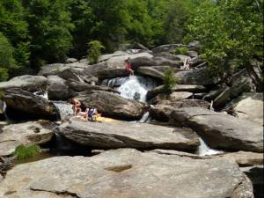
September
Price park - Blue Ridge parkway camping
Price park Milepost 297 Blue Ridge Parkway, Blowing Rock, NC 28605 (1 hour 45 minute drive)
http://www.recreation.gov/camping/julian-price-blue-ridge-pkwy/r/campgroundDetails.do?contractCode=NRSO&parkId=74043
Comments: Great place in troop 942’s backyard and these trails are really pretty and fun. Option to back pack into to Pisgah national forest Commissary Hill spot to camp out Saturday night.
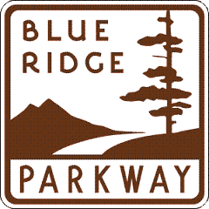
September or October
Navigators only trip & Adventurers only trip
Blue Ridge Pkwy: Price park, Rocky knob, Doughton Park https://www.nps.gov/blri/planyourvisit/doughton-park-trails.htm , Linville Falls http://www.hikinginthesmokys.com/linville_gorge.htm, Crabtree Meadows

October each year
Out house race & River camping
New River Campground Inc 6286 US-21, Sparta, NC 28675 (336) 372-8793 (hour 20 minute drive)
Mountain Foliage Festival & Grand Privy Race http://www.graysoncountyva.com/festivals
Comments: This could be fun laid back trip trailman would race an outhouse/portapotty down the middle of the town. Kinda like a Chinese fire drill where every member has to sit on the toilet during the race. Funny and will not be forgotten soon

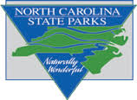
December or January
Navigators only trip OR Adventurers only trip? State parks: Hanging Rock, Stone mountain, Pilot mountain (50 minutes)

BIKING = ONE CAMPING TRIP
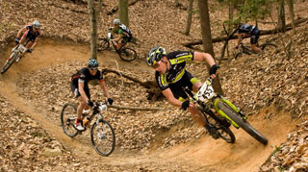
November or December 1 ml
Lake camping and Single Track Mountain biking
W. Kerr Scott Dam & Reservoir, NC 99 Reservoir Road Wilkesboro, NC 28697-7462 Phone:(336) 921-3750 (one hour drive)
Bandit’s Roost, NC group camping
http://www.recreation.gov/camping/bandits-roost/r/campgroundDetails.do?contractCode=NRSO&parkId=73074 Overmountain Victory Trail - Single track mtn biking http://brushymtncyclists.com/mountain-biking/ Comments: Some trailman might be tired of doing the New river trail or Va Creeper. Well single track mountain biking is like nothing else they will experience. Kerr Scott has some really amazing trails. The troop can do some single track mtn bike training locally and we can even put on simple clinic at the church or someone’s home that will prepare trailman on how to use their bike on single tracks. Also IF WE can get someone to bring their SKI boat this could be fun.

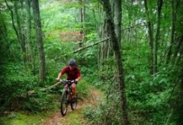
April – May Iron Mountain Trail (2.5 hrs) North - Hurricane Mountain Mt Rogers National Scenic area to Damascus a 20 mile decent into Damascus. After you have done the VA creeper enough times and want to ride on former section of the Appalachian Trail with your Mountain Bike. Pretty neat experience. Friday night Camp at Bear Tree recreation Area (access via Lum Trail https://www.mtbproject.com/trail/899310/lum-trail ). Saturday night camp Sandy Flats area down Feathercamp Branch Trail or Trestle 18 on Virginia Creeper. Chilhowie Virginia 24319 36.702524, -81.544517, or Rye Valley Virginia 36.699758, -81.557723 or Rye Valley Virginia 24319 36.702906, -81.610382 or
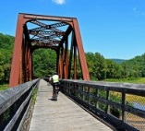
October
New River Trail State Park 116 Orphanage Dr, Max Meadows, VA 24360 (1 hr 45 min) Rails To Trails Biking or Canoe trip
Notes: easy classic trip the troop has done many times. IF you go in Summer or Spring the rangers offer an inexpensive & short caving trip

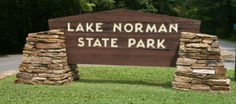
October, November, (maybe summer)
Lake adventure and Single track biking trip
Camp: Lake Norman State Park 159 Inland Sea Lane Troutman, NC 28166 (704) 528-6350 (one hour drive)
http://www.ncparks.gov/sites/default/files/ncparks/maps-and-brochures/lake-norman-group-camping.pdf
Hike: Lake Shore Trail 6 miles – this trail was voted a favorite trail by folks in Charlotte. Orienteering course at Lake Norman
Bike: Itusi Trail system = Hawk trail or Norwood trail for beginners and Mondo for more adventurous. http://www.mtbproject.com/trail/1103692
Comments: LakeSingle track biking, Swiming beach, IF WE can get someone to bring their SKI boat this could fun. This could be a laid back trip..
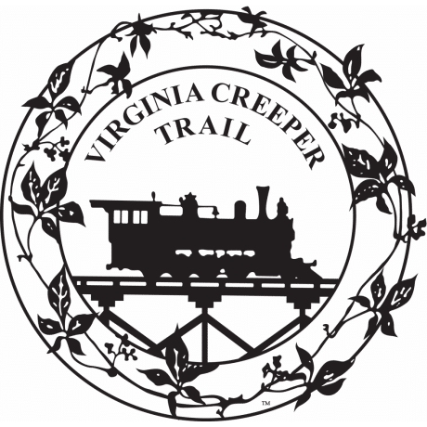
May
Virginia Creeper Rails to Trails bike trip
Camp: at the top of the mountain- Creeper Trail Campground 2248 Whitetop Gap Rd, Whitetop, VA 24292 (276) 388-3426
Notes: Campground might cost a little more but it is at the starting point of the trail makes things much easier.

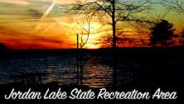
October or June?
(Spring or Summer) Easy Biking and Lake camping trip
Camping = Jordan Lake State Recreation Area , Parkers Creek Campground group camping (hour & 45 minute drive) http://www.ncparks.gov/sites/default/files/ncparks/maps-and-brochures/JORD_ParkersCreek15.pdf
Parkers creek beach road, Chapel Hill NC 919-362-0586
Hike = New Hope Trail 5 mile loop http://www.ncparks.gov/jordan-lake-state-recreation-area/trail/new-hope-trail
Bike = American Tobacco Trail (22 miles - Starts near Jordan lake) 1309 New Hill Olive Chapel Rd, Apex, NC 27502 to 518 Morehead Ave, Durham, NC 27707 maybe eat lunch at Mellow Mushroom, Rails to Trail/Greenway http://www.triangletrails.org/pdfs/ATT-Guide.pdf ) Other= Forest ranger led education: Jordan Lake Educational State Forest, Bald Eagle viewing, Tiger zoo

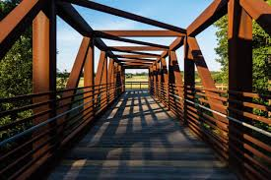
Neuse river greenway trail - camp at Falls Baptist Church 9700 Fonville Rd, Wake Forest, NC 27587 +1-919-847-0870 http://www.fallsbaptistchurch.org/ Start at Falls Lake Tailrace 12098 Old Falls of Neuse Rd, Raleigh, NC 27614 go 18 miles to a midway point at Anderson Point Park 35.772292291427554, -78.54331119935753. If still interested head to near the end to Mile post 26 at 6008 Mial Plantation Rd, Raleigh, NC 27610 or milepost 27 at 2671 Covered Bridge Rd, Clayton, NC 27527.
https://www.traillink.com/trail-maps/neuse-river-trail/

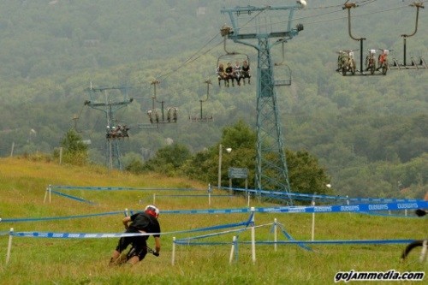
May-June-July 1 ml
Down Hill Mountain Biking $$ –Beech Mountain
Mountain Biking out west has been doing biking down mountains since the 70’s in the last 5 to 10 years ski sloops on the east convert their ski runs to bike trails and the best on in NC is Beech mountain.
https://www.beechmountainresort.com/summer/mountain-biking/
Camp site: Grandfather Campground Pisgah National Forest, 125 Riverside Dr, Banner Elk, NC 28604 (828) 963-7275 OR ?Buckeye Recreation Center in Beech mountain?
Notes: The biggest concern about doing an event like this is the cost. It is strongly suggested to rent a full suspension bike with all of the safety gear. Full suspension bike rental $60/half day or $80/day, Full-face helmet – $20 to $40 depending on style – Trail man could share a bike if needed - Need to do fundraising
BEACH CAMPING TRIPS
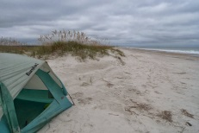
November
Beach camping at Masonboro Island NC Coastal Reserve largest undisturbed barrier island on the NC coast. Easy trip to just hang out on the island right beside Wilmington. 5600 Marvin K Moss Ln, Wilmington, NC 28409 (910) 962-2998 (3 hour 50 minutes) Shuttle $30 ea https://wrightsvillebeachscenictours.com/product/masonboro-cruise/

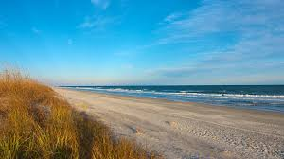
October or Maybe June? 1 cobra
Beach camping 2, Fishing & Crabbing
Huntington Beach State park, 16148 Ocean HWY Murrells Inlet, SC (4 hour drive)
http://www.southcarolinaparks.com/huntingtonbeach/introduction.aspx
Comments: More isolated beach that isn’t as busy as Myrtle Beach. Fun Fishing on the Jetties and Murrells Inlet is Great for crabbing.
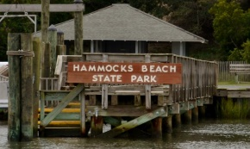
Beach camping - Hammocks Beach State Park - 4 hrs - A crown jewel of the North Carolina coast and Hammocks Beach State Park is Bear Island—a 4-mile-long, undeveloped barrier island

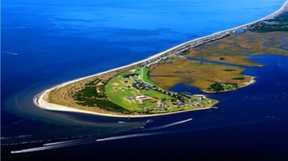
November or October
Fort Caswell $$ Cool weather beach trip (another option for a fishing trip) 4 hour drive
(910) 278-9501, 100 Caswell Beach Rd, Oak Island, NC 28465
http://www.fortcaswell.com/projects/2016-brochure/
Lodging: Barracks only – no primitive camping allowed. Comments: Tucked away on the eastern tip of Oak Island, the North Carolina Baptist Assembly at Fort Caswell occupies the site of a former Civil War fort. I have always been curious about this awesome place looks like a perfect fit for Trail Life. Also for those not interested in fishing of just beach stuff they could take a ferry over to North Carolina Aquarium At Fort Fisher.
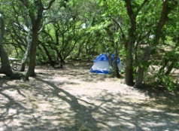
.
Summer
First Landing State Park 2500 Shore Dr, Virginia Beach, VA 23451 (4 hours 4 minute)
The most popular state park in Virginia and a big place. Worth the drive to Virginia Beach. Lots of day trip opportunities

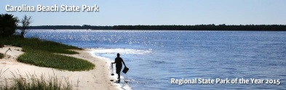
Fall or Spring
Carolina Beach State Park 1010 State Park Road Carolina Beach, NC (4 hr drive) https://www.ncparks.gov/carolina-beach-state-park/camping Hike: Sugarloaf trail and Flytrap trail Comments: Park is NOT on the beach on the intracoastal waterway so no swimming. Super popular park due to being near the aquarium at Fort Fisher and close driving distance Carolina & Kure Beach. In Wilmington there is Battleship NORTH CAROLINA, The Cape Fear Museum and a favorite for some the Cape Fear Serpentarium

FISHING = ONE CAMPING TRIP
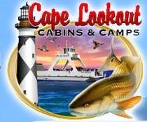
November 1 ml, 1 Cobra
Coastal Fishing 1 $$& camping trip
Davis Island/Cape lookout http://cape-lookout-cabins-camps-ferry-davis-nc.com/ http://www.davisferry.com/ 148 Willis Davis NC (4 hour 45 minute drive) Comments: Great place to fish and going in November is when the bigger fish run. You can rent ATV golf carts to move down the island for better fishing locations. They have cabins and primitive camping. For what it is not too expensive. This is the place for Big fish. I have pictures to prove this. Trail man need to purchase rain suits if they do not have them., $16.00 ferry cost, $150 per day on ATV if interested, $ bait, Tent camping free, Must leave 1:00 PM or leave later anoe .
November Coastal Fishing 2 – & camping trip 1 buffalo
Camp = Pettigrew State Park 2252 Lake Shore Rd, Creswell, NC 27928 https://www.ncparks.gov/pettigrew-state-park (252) 797-4475 (4 hours) Notes: 1 hour drive to Nags head where if fishing stinks there are lots of other options.

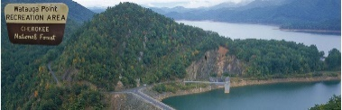
June or August
Lake Trout fishing trip at Watauga lake ! Trail men 16 yrs and older will need a trout license $27.00 and trout rigs.
https://www.fs.usda.gov/recarea/cherokee/recarea/?recid=34992
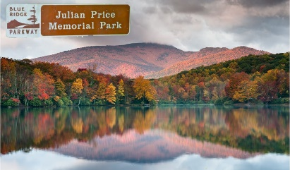
Trout fishing at Price Park AND some great trails = Boone Fork Trail, Green Knob Trail, and the Tanawha Trail https://www.nps.gov/blri/planyourvisit/julian-price-trails.htm

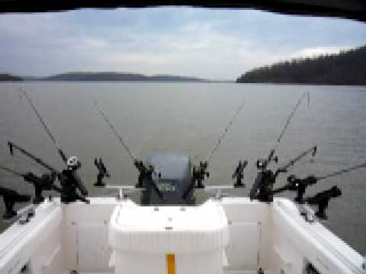
June – July
Fresh water fishing Badin Lake
Badin Lake Group Campground Uwharrie National Forest, New London, NC 28127 (1 hour 20 min)
http://www.northcarolinasportsman.com/details.php?id=4308 Notes: If we could recruit some boating fishermen and really try to give a trail man new experience fishing instead of sitting on a bank somewhere. Maybe we could hook up with http://www.fomntt.com/index.cfm jsnincak@fomntt.com John Snincak Fishers of Men C:803-487-3216 or Arrow Head campground

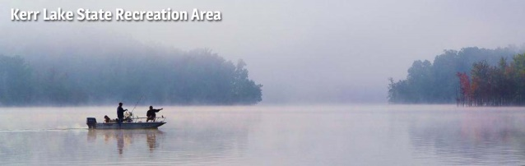
August
Kerr Lake Recreation area 6254 Satterwhite Point Rd, Henderson, NC 27537 (2 Hr drive) - Lake swimming and Fishing - One of the best fishing lakes in the eastern United States. A easy laid back relaxing Summer weekend trip. If we had a friend of the troop bring a ski boat even more fun could happen. Group Camping at Satterwhite Point
March-April-May
Falls Lake State Recreation Area
Camping = group camping Rolling View 4201 Baptist Road, Durham, NC (1 hr 45 min) or back packing Shinleaf = 13708 New Light Road, Wake Forest, NC 27587 https://www.ncparks.gov/falls-lake-state-recreation-area/camping
Hike: Mountains to Sea trail 8.8 mile Section 1 = Midpoint of Little Lick Creek Bridge west to Cheek Road 4.7 miles, Rollingview to Little Lick Creek 4.1 miles
OR - Section 2 = NC 98 to Rollingview Recreation Area 3.2 miles https://mountainstoseatrail.org/segment/10/ Other: Swimming beach & other lake stuff

WHITE WATER RAFTING TRIP
June, July, or August 1
U.S. National Whitewater Center trip $$ 5000 Whitewater Center Pkwy, Charlotte, NC 28214 http://usnwc.org/
Camp: Copperhead Island camping at Mcdowell preserve 15200 soldier road Charlotte NC Chad Moore Ryan.moore@mecknc.gov 980-722-2315
Notes: Day pass = $59 each (two white water trips, zip lines, mountain biking and rope courses)

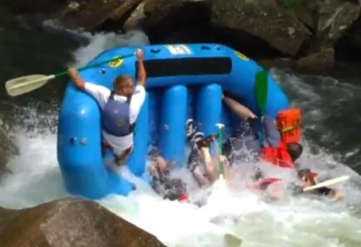
August White water trip
Nantahala river $$ - Rolling Thunder River Company http://www.rollingthunderriverco.com/ (4.5 hr drive), Nantahala Power Plant to Wesser (Lower Nantahala) http://www.americanwhitewater.org/content/River/detail/id/1101/ (less expensive $35.00 per person)
OR French Broad trip – Hot Springs Rafting http://www.hotspringsraftingco.com/whitwater-rafting-guided-trips/ which is closer to Asheville (3 hr drive) less crowded. French Broad river section 9 http://www.americanwhitewater.org/content/River/detail/id/1074/ ($46 to $50)
Camp: Nantahala - at Rolling Thunder River Company 10160 Highway 19 W Bryson City, NC 28713
Camp: French Broad - Rocky Bluff Campground 2145 NC-209, Hot Springs, NC https://www.fs.usda.gov/recarea/nfsnc/recreation/wateractivities/recarea/?recid=48602&actid=43
Upper Pigeon River $$ – Camp at Pigeon Valley Church (Billy Moore 3166 Big Creek Rd Hartford, TN 37753 423-487-5579) Friday – Max Patch camp on Saturday night
Ocoee River Rafting: Middle Ocoee $$ 5 hour drive Friday Camp at Camp Fletcher 1412 Cookson Creek Rd Ocoee, TN 37361 and GPS as 35.106870, -84.680454 Mike Stoess fletcherprogram@gmail.com Mike@ANDORCleveland.org 423-464-2068, Saturday morning Rafting Adventures Unlimited 522 US-64, Ocoee, TN 37361 (423) 338-4325 https://www.adventuresunlimited.net/ or Sunburst Adventures 702 Welcome Valley Rd, Benton, TN 37307 (423) 299-9625 https://www.facebook.com/Sunburst-Adventures-Whitewater-Rafting-117601131138/ then Drive to back in Asheville maybe camp at Grove church 14 Mineral Springs Rd. Asheville, NC 28805 - (828) 255-8245. It might be possible to schedule a Saturday night speaker from https://teen.wng.org/ Or Grove church pastor Lance Michels for Sunday morning. Info on the river section = https://www.americanwhitewater.org/content/River/view/river-detail/1780/main
Summer Weekend before or after Public School is out (June 1st or 8th 2018)
Dan River camping on the Dan River beside Hanging Rock State park – $ END the School Year Tubing trip!
Camp on river: Lewis & Maxine Wood’s Camp (336) 593-8648 1157 Wood Rd Danbury, NC 27016 (L-Sheppard Mill Road”Moratock park” L-Pleasant View Church “Priddy’s”, L-Wood “Lewis & Maxine Wood 2nd house for key” OR $22.00/16 people/night + tubing cost or Jessup Mill 1565 Collinstown Road, Westfield, NC 27053 or http://www.buckislandcampground.com/
Comments: Friday River camp, Saturday TRAILS END Ceremony = Timberline Hike/Moore's Wall Loop Trail down to Moore’s Wall climbing access, Sunday afternoon Tubing trip. Very popular campground that you have to make reservations way in advance. This could be another laid back weekend where we can rent some tubes or canoes and float down to moratock park. This could even be used for an end of the year event if the Moores wall climbing access didn’t work out for some reason. http://www.danburygeneralstore.net/

CAVING CAMPING TRIPS
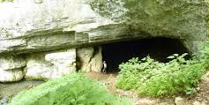
Caving trip 2! $$ Worleys cave - 461 Timber Ridge Rd, Bluff City, TN 37618 (3 hour drive)
http://tennesseecaving.com/ $40.00 ea or do it on our own buy our own helmets.
Camping: at the Cave (http://www.acave.us/ https://caves.org/grotto/flittermouse/photos/ )
828-260-1717
Melanie and John caveguides@gmail.com
Comments: This is a cave Troop 942 has been to.
Xinda Professional Mountaineer Rock Climbing - $17.87 ea

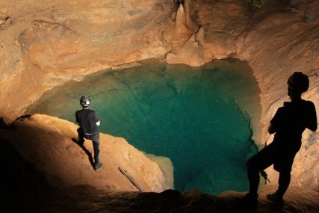
March or April 1 cobra, 1 buffalo
Caving trip 1! $$ Carter Saltpeter cave - 105 John Sheffield Drive in Elizabethton TN. (3 hour drive)
http://tennesseecaving.com/
Camping: Cardens Bluff Campground US-321, Hampton, TN 37658 http://www.reserveamerica.com/camping/cardens-bluff-campground/r/campgroundDetails.do?contractCode=NRSO&parkId=122390
Or if we contact Hunter First Baptist Church maybe they would allow us to stay on their church grounds… http://www.hunterfbc.org/ Comments: A new cave the troop hasn’t done

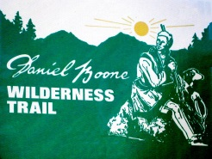
April or spring
History trip / Cave trip
Cumberland Gap National Historical Park 854 National Park Road, Ewing,VA (4 hours) https://www.nps.gov/cuga/index.htm
Hike – the Wilderness road trail that Daniel Boone took Cave tour – We can also schedule tour of Gap Cave https://www.nps.gov/cuga/planyourvisit/guidedtours.htm
Other Caves: Gilleys Cave Pennington Gap VA, Carson Campbell Tazewell Tenn, Rehoboth Church Cave West VA, SCOTT HOLLOW CAVE West Va, Grindstaff Cave Hampton TN

WATERFALLS CAMPING

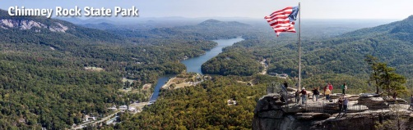
Spring or Fall
Chimney Rock State Park & Lake Lure
Camp: http://www.rivercreeknc.com/ 217 River Creek Drive Rutherfordton, NC 28139 (2 hours)
Hike: The Peaks Trail or Eagle Rock Trail and many other short trails

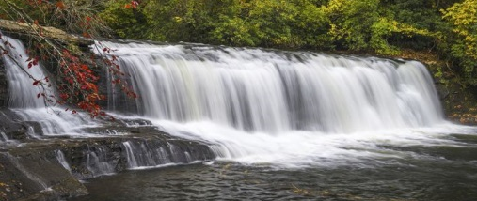
June
Large water fall viewing and mountain biking
Camp at: Holmes Educational State Forest Group site 1299 Crab Creek Rd, Hendersonville, NC (828) 692-0100 (3 hour drive) http://www.ncesf.org/hRecreation.html
Bike or Hike at: DuPont State Recreational Forest, 89 Buck Forest Road, Cedar Mountain, NC 28718
http://www.dupontforest.com/explore/high-falls/
Comments: One of neatest places in NC to see many large water falls in one place with tons of easy and challenging hiking options. A couple of Hollywood movies were filmed here. Hunger games. OR visit Mountain Bridge Wilderness Area of South Carolina at Caesars Head and Jones Gap state park to do the Jones Gap trail with more Waterfalls: https://rootsrated.com/stories/why-you-should-visit-jones-gap-state-park
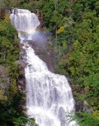
May-June
Gorges State Park 3 ½ hour drive 976 Grassy Ridge Road Sapphire, NC 28774
Camp site: Ray Fisher Primitive Campground
Hike: The Foothills Trail 6.7 mile, Canebrake Trail 10.4 mile Comments: this brand new state park opened in 2009 has some beautiful water falls. The Foothills
Trail section is part of NC/SC 76 mile trail that leads to the tallest waterfall east of the rockies White water falls at 811 feet.

May
LINVILLE FALLS
Car camp 717 Gurney Franklin Rd. Linville Falls, NC 28647 (2 hours) 828-765-1045 – NPS campground https://www.recreation.gov/camping/linville-falls-campground-blue-ridge-pkwy/r/campgroundDetails.do?contractCode=NRSO&parkId=74042
Hike: Day hike around Linville Falls, Evening head up to Wiseman's View to watch sunset and look for the brown mountain lights!
https://www.romanticasheville.com/brown_mountain_lights.htm . If interested in Back Packing Linville Gorge another plan would be needed.

HISTORICAL PLACES FOR CAMPING
November (Saturday after Veteran’s day) OR MAY Weekend before Memorial day 1 cobra
Veterans day weekend parade near Ft Bragg OR Weekend before Memorial Day for the Field of Honor (giant field of flags to honor veterans – Troop 942 could sponsor chosen veteran from our town or area) http://www.ncfieldofhonor.com/
Camping at: Raven Rock State park http://www.ncparks.gov/raven-rock-state-park ( 1 hour 45 minute drive)
Also go to Airborne & Special Operations Museum & Great opportunity to do the OUR FLAG trail badge or Tryout BLACK OPS AIRSOFT.
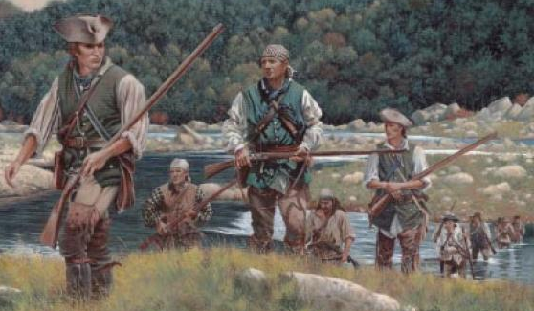
June or July
Kings Mountain State park & The Overmountain Men revolutionary war history
Camp at Kings Mountain State Park group site 1277 Park RD Blacksburg, SC 29702 (2 hr 15 minute drive) http://www.southcarolinaparks.com/kingsmountain/introduction.aspx
Hike: Kings Mountain Hiking Trail 16 miles History: Visit Kings Mountain National Park. The Battle of Kings Mountain Thomas Jefferson called it, "The turn of the tide of success." It really is an amazing story and battle unlike any other. Almost a year later the British surrendered in Yorktown. Also there is well known play called Liberty Mountain that is very good I understand a short distance from the Campground in Kings Mountain NC. http://www.libertymountaindrama.com/

April 26-28 2019
BIRTH OF THE US and BATTLE YOUR FELLOW TRAILMAN WITH AXE & SWORD!! Saturday morning visit the AMAZING Museums at the Jamestown settlement and then in the afternoon battle it out Medieval style!!
Medieval Combat Camp, Troop VA‐4031 Eastover Retreat Center 8627 Colonial Trl W, Spring Grove Virginia (4 hour drive). $35.00 Pete Dowdy petedowdy1911@gmail.com, TrailLifeSEVA@gmail.com

Summer Adventure - Day 1 Jamestown Settlement, Day 2 Yorktown Victory Center, Day 3 Busch Gardens http://www.historyisfun.org/
Camp at Chippokes Plantation State Park 695 Chippokes Park Rd, Surry, VA 23883 ( 4 hours and 20 min) Comments: Both the Jamestown Settlement and the Yorktown Victory Center have new, world class amazing museums. You can spend a day at each and there is Bush Gardens & Water Country USA if needed.
Spring
Gold Mining Camp & Mine: http://www.thermalcitygoldmine.com/ 5240 US 221 North Hwy, Union Mills, NC (two hours)

SPECIAL EVENT CAMPING TRIPS
Spring (Mid-April 2018)
Coastal forest camping & Marine base Air show = Croatan National Forest
April 2018 MCAS Cherry Point Air Show http://www.cherrypointairshow.com/
Flanners Beach/Neuse River Campground (3 hour 45 minute drive)
http://www.fs.usda.gov/recarea/nfsnc/recreation/camping-cabins/recarea/?recid=48472&actid=33
Comments: other Trail Life troops have done this before so we could talk to them some stayed on the Marines base. I have heard for years how awesome these air shows are.
May 20th 2017
Eastern North Carolina camping & Air show
Wings Over Wayne Air Show Seymour Johnson Air Force Base, Wright Brothers Avenue Goldsboro NC 27531
Cliffs of the Neuse State Park Camping http://www.ncparks.gov/cliffs-of-the-neuse-state-park (3 hour drive) Comments: Air shows rotate every year at two military bases so here is another opportunity.
April or September 1 ml
Drag Racing$$: NHRA 4 wide nationals
Camp: at race track Winner's Circle Camping 4418-4498 Concord Pkwy S, Concord, NC 28027 (704) 791-4684
Note: This is most amazing sport you will ever see live. You will never forget this experience. 15 Tickets = $36.11 or 32.10 (East side Grand stand buy 3 & one free) 1-800-455-3267 - Budget Porta Potty Rental Concord (704) 946-6141 $160.00
June or July WAKE BOARD & WATER SKI PARKS
$$ Wake Zone Cable Park 1200 Honeycutt Rd Fayetteville, North Carolina
East Coast Wake Park Greenville, North Carolina 27858 https://www.facebook.com/The-East-Coast-Wake-Park-157070041146/ Jibtopia Semora, NC 27343 http://jibtopiawakepark.com/pages/features/ Notes: This can be expensive. Need to do fundraising for trip cost
September $$ ( 9/24/16 this changes each year)
Carowinds & Camping weekend
Copperhead Island camping at Mcdowell preserve 15200 soldier road charlotte nc http://charmeck.org/mecklenburg/county/ParkandRec/StewardshipServices/Outdoors/Pages/Camping.aspx
OR camping at Camp Wilderness at Carowinds: https://www.carowinds.com/places-to-stay/carowinds-camp-wilderness-resort or http://www.simusa.org/ 14830 Choate Cir, Charlotte, NC 28273 (one mile from Carowinds) John Hardy Campus Operations Manager 704.587.1456 828.244.4071 john.hardy@sim.org (they have small campground that we could use) Carowinds for Christian Music Day http://www.christianmusicday.com/ Pretty fun weekend, bring your ear plugs!!

June (check the web address for dates that change each year June 11th 2016) 1 wolverine
Carowinds $$ & Camping weekend Copperhead Island camping at Mcdowell preserve 15200 soldier road charlotte nc http://charmeck.org/mecklenburg/county/ParkandRec/StewardshipServices/Outdoors/Pages/Camping.aspx
OR camping at Camp Wilderness at Carowinds: https://www.carowinds.com/places-to-stay/carowinds-camp-wilderness-resort or http://www.simusa.org/ 14830 Choate Cir, Charlotte, NC 28273 (one mile from Carowinds) John Hardy Campus Operations Manager 704.587.1456 828.244.4071 john.hardy@sim.org (they have small campground that we could use) Carowinds for Rock the park http://www.rocktheparkfest.comComments: Pretty fun weekend, bring your ear plugs!!

August (end of month) FAITH FEST – W. Kerr Scott Dam & Reservoir – MTN Biking August (end of month) Wilkesboro Community College, Camp at Bandits Roost campground – Mountain bike the Overmountain Victory trail or do Lake things. Saturday do things at Keery Scott and during evening listen to some great music!!! Pretty fun times! https://faithfestnc.com/ http://www.recreation.gov/camping/bandits-roost/r/campgroundDetails.do?contractCode=NRSO&parkId=73074 Overmountain Victory Trail - Single track mtn biking http://brushymtncyclists.com/mountain-biking/
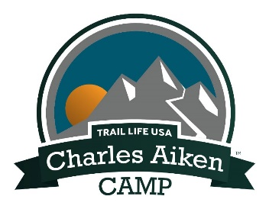
September (third weekend)
Night Ops TRAIL LIFE NATIONAL - Camp Aiken in Belton, SC Competing in patrols, their skills in first aid, night navigation, fire, water, and teamwork will be put to the test. Come prepared to stay up late, solve challenges, and have lots of fun! Non-participating, registered youth may also come campout that weekend. The debriefing/award bonfire is at noon on Saturday to allow time for Troops with Sunday commitments to get home. Troops may stay until Sunday if they wish. http://nightopsadventures.com/
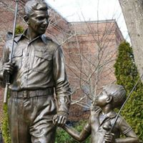
November
NC Story Telling Festival 218 Rockford St, Mt Airy, NC 27030
https://www.facebook.com/heartofnorthcarolinastorytellingfestival/
Camp maybe in downtown Mt. Airy, NC
OK this isn’t the typical camping trip, but might be something new and fun. We could have a meet up with the Trail Life Mt. Airy Troop.

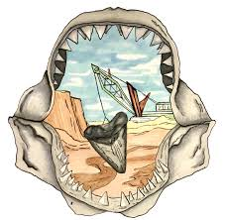
May (Memorial day weekend)
Aurora Fossil Festival - Camp in Washington NC with new Trail Life troop NC-2206 (Chris Whitford 252-340-2221). – Maybe spread the word of Trail Life attending festival by informally handing out NC2206 cards about the new troop. https://aurorafossilfestival.net/ http://aurorafossilmuseum.org/ Visit North Carolina Estuarium https://www.partnershipforthesounds.net/nc-estuarium Maybe do a river tour ESTUARIUM RIVER ROVING.

FITNESS ACTIVITY CAMPING TRIPS
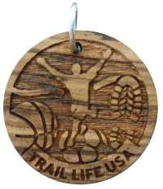
Do a 5k race! $$ Sports and Fitness Elective Award – This is an achievement for Adventurers, but doing a 5k is great experience for all trailman. We could do early training runs at Tanglewood in the mornings to get prepared.
March - THE COLOR RUN http://thecolorrun.com/locations/winston-salem/ Super fun run and one of the largest running organizations in the USA – We could possibly find someone that would allow us to pitch a tent one night or we do a lock in at the Trail Lodge
March – NATHAN’S RACE might be kind of great to hook up with the school and could be great PR if we all wear trail life t-shirts.
January – THE RUNNING OF THE LIGHTS http://runningofthelights.com/ Another fun option. We could have a lockin at the trail lodge
June – THE MARINE MUD RUN http://usmcmudrunnc.com/ At jomeokee park. The mud run has two courses the Pollywog Mud Run for those less inclined for the bigger challenge.
September $$(usually mid September)
Tour to Tanglewood
This would need to planned many months in advance. Basically each trail men would need to raise $300.00 + a registration fee. The 2 day Bike ride/race begins and ends at Tanglewood and specific route distance can be selected 35, 50, 65, 80, or 100 Miles. Camping at Tanglewood and food are typically included. This is a super event that is done really well. Super fun!

OTHER TRIPS

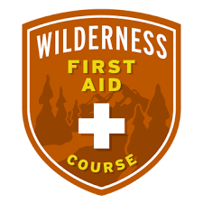
Yearly
WILDERNESS FIRST AID $$ various places in the state at various times of the year. This great education for the First Aid Trail Badge. Out Door mission Camp https://www.outdoormissioncamp.org/ in Maggie Valley has offered this to troop 942 for $200.00 This includes first aid Wilderness, CPR, AED training, Lodging, and food for two days. Can’t beat this deal. The catch is it is usually scheduled on a Monday & Tuesday in June each year. Other First Aid Wilderness classes are done all around the state Boone, Asheville, Raleigh, Greensboro, Uharrie Forest, or Bryson City. These usually the cost ranges from $179 to $220 per person not include other costs. https://noc.com/lessons-training/solo-wilderness-medicine/wilderness-first-aid-certification-course

Summer Adventure Ideas – NOTE SUMMER ADVENTURE FUNDRAISING PLANS REQUIRED

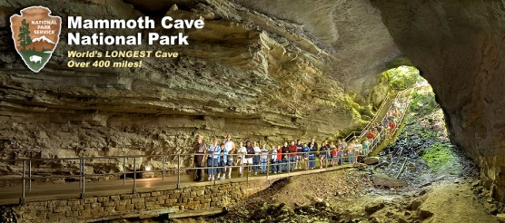
Summer Adventure trip 6 to 7 day trip
Mammoth Cave National park/Creation museum/Ark Encounter, National Air force Museum
Mammoth Cave National Park, 1 Mammoth Cave Parkway, Mammoth Cave, KY 42259 (7 hour drive)
https://www.nps.gov/maca/planyourvisit/camping.htm Wild Cave Tour
Creation Museum/Ark Encounter 2800 Bullittsburg Church Rd, Petersburg, KY 41080 https://arkencounter.com/ & http://creationmuseum.org/ Camping = Big Bone Lick State Park 3380 Beaver Rd, Union, KY 41091 http://parks.ky.gov/parks/historicsites/big-bone-lick/reservations.aspx or http://www.oakcreekcampground.com/reservations.htm or http://hoosierhillsbaptistcamp.org/ National Museum of the Air Force 1100 Spaatz St, Dayton, OH 45431 http://www.nationalmuseum.af.mil/ Camping = Dayton KOA 7796 Wellbaum Rd, Brookville, OH 45309 (937) 833-3888 http://koa.com/campgrounds/dayton/
Comments: 7 hour drive to Mammoth cave (day & ½) Wild Cave tour, 3 hour drive to Creation Museum/Ark Encounter (2 Days), 1 ½ hour drive National Air force Museum (beats all other aerospace museum hands down). 9 hours drive home.

Summer Adventure Bike Packing trip 1 in West Virginia
Green Brier trail http://www.greenbrierrailtrailstatepark.com/
Cass WVA to Caldwell 78 miles Or Marlington to Caldwell 53 miles
Starting camp at http://www.greenbriersf.com/ 1541 Harts Run Rd Caldwell, WV 24925 (304) 536-1944 – (3 hr & 45 minute drive) Comments: This is also something Trailmen will not soon forget. The Green Brier trail is a 78 mile rails to trail that has tons of camping sites right on the trail. It is like the AT style mtn biking with little shelters , water, etc.. pretty neat. To save cost we would get one adult to shuttle trail men to one end and pick them up at the end. Due to travel and trail time this would need to be done in the summer over a little more than a weekend. Instead of back packs Trail men need to purchase large dry bags from Walmart and racks for their bike.

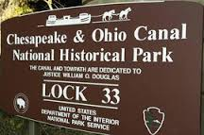
Summer Adventure Bike Packing trip 2 in Harpers Ferry West VA to Washington DC 1 buffalo
Chesapeake and Ohio Canal trail: http://www.bikewashington.org/canal/
Harpers Ferry West VA to Washington DC (62 miles)
Start at http://www.campingharpersferry.com/ 408 Alstadts Hill Rd. Harpers Ferry, WV 25425 (5 ½ hour drive) There are quite a few free campsites on the trail to DC. https://www.nps.gov/choh/planyourvisit/camping.htm
Comments: One of the best Rails to Trails in the USA. We could take a couple extra days to visit Washington DC and stay in a Hostel if needed. http://hiwashingtondc.org/ . In DC among the many museums we could visit the brand new Museum of the Bible. It costs money and time but we could drop cars of in DC get on an Amtrak and ride to Harpers Ferry to start the bike trip. https://www.amtrak.com/trails-rails-heritage-appreciation-during-your-train-ride Instead of back packs Trail men need to purchase large dry bags from Walmart and racks for their bike.

Outdoor Mission Community pretty neat place in the NC mountains. This group can take the troop on a long term high adventure trip in the Great Smokies Mountains. 3190 Fie Top Rd Maggie Valley, NC 28751. This could be lower cost option for a summer adventure than Camp Glorieta. https://www.outdoormissioncommunity.org/
Summer adventure ?June Atlanta Fest? 4 days possibly?
http://atlantafest.com/ 4200 Strong Rock Pkwy, Locust Grove, GA 30248 (5 hr 45 min)
Camp at Sweetwater Creek State Park https://gastateparks.org/SweetwaterCreek/
Nationally known Christian Music Festival below Atlanta. Some awesome music
Notes: Could visit the big city of Atlanta maybe the Georgia Aquarium among other things.

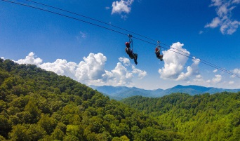
Summer Adventure
Mountain top to Mountain top ziplines:
NAVITAT Zip lines 3600 ft long, 350 ft high, and 65 miles per hour. One of longest and highest Ziplines in the southeast. http://www.navitat.com/asheville-nc/ 242 Poverty Branch Rd. Barnardsville, NC 28709
Camping – Primitive – Back packing style camping at Big Ivy Area, Coleman Boundary https://www.fs.usda.gov/recarea/nfsnc/recarea/?recid=70825
OR THE GORGE ZIPLINE America’s Steepest and Fastest Zipline. https://thegorgezipline.com/ 166 Honey Bee Drive, Saluda, NC 28773
Camping - Wilderness Cove Campground 3772 Green River Cove Rd. Saluda, NC 28773 (2hrs 45)
Comments: Kind of a bucket list thing. Though this could be out of reach for the average trail man due to cost of $99.00 each. Fund raising plan is a must before anything like this could be planned http://www.citizen-times.com/story/carol-motsinger/2014/04/08/navitat-opens-highest-longest-zipline-in-the-southeast/7478361/

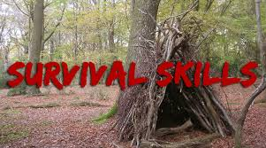
Wilderness Survival camps at Mountain Shepherd Wilderness Survival School 57 Hemlock Ridge Ln, Catawba, VA 24070 ( 2 ½ hour drive) OR The Nantahala Outdoor Center 13077 W Hwy 19, Bryson City, NC 28713 (3 ½ hours)
https://mountainshepherd.com/home-2/custom-courses/ OR https://noc.com/lessons-training/wilderness-survival-school or http://www.christianwarrioradventurecamp.com/c-a-s-t-survival-training/

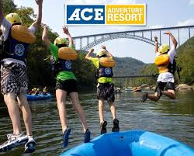
Summer Adventure
Whitewater Trip & Camping on the New River
New River Gorge – National Park –National River West Virginia
ACE Adventure Resort 1 Concho road, Oak Hill, WV 25901 (3 hour drive) https://aceraft.com/product/lower-new-river-overnight-2-days/
ACE is where the Trail Life National camp was here few years ago so this would really great bucket list kind of option to whitewater and camp on the New River. Similar to the Summit Bechtel Family National Scout Reserve
OR Camp: Brooklyn campground Cunard River Access Road, Fayetteville, WV 2584 (3 hour drive) OR Babcock state park 486 Babcock Rd, Clifftop, WV OR Mountain Top Camping at ACE Adventure Resort https://aceraft.com/product/mountain-top-camping/
OR Hike: Long Point Trail & others https://www.nps.gov/neri/planyourvisit/hiking.htm

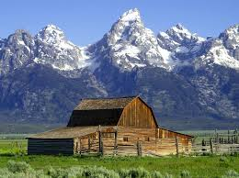
Summer – July
Jackson Hole, Wyoming & Grand Teton National Park
http://www.christinthetetons.com/
This is bucket list trip that would have to be worked on to be affordable even with fund raising. Christ in the Tetons is an organization that uses Manhood as theme for the trip. Their curriculum is the same one Trail life uses for the Timberline while also using other Robert Lewis manhood concepts. So this would be an experience visually and mentally that Trail men will never forget.
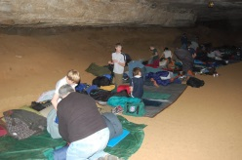
Summer
Camp in a Cave
Cumberland Caverns 1437 Cumberland Caverns Road McMinnville, Tennessee (6 hour drive) http://cumberlandcaverns.com/product/camping-caving-special/ OR drive to first to (3 hours) Fox Fire Riverside Campground Cherokee National Forest, 3541 Hartford Rd, Hartford, TN 37753. We could stop on the way to do some things if time

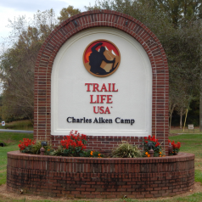
Summer
Trail Life Camp Aiken
10612 Augusta Road, Belton, SC (3 hour drive)
https://traillifeusa.configio.com/page/camp-aiken
Day trip hikes: Swamp Rabbit Trail, Foothills trail, Caesars Head, and Jones Gap state park (Maybe go when something is happening in the area or at the camp)

Summer
Lead with Character
An amazing trip to Civil War battlefields. Follow the story of four Generals in the Civil War at Specific battlefields (Gettysburg, Sharpsburg,VMI) and how they finished their life. You will learn leadership character traits on each General. This is a perfect trip for Fathers and Sons of Trail man. Many Trail men in 942 have been on these trips in the past. So this weekend trip gets very high marks. For more info go to: https://www.leadwithcharacter.com/

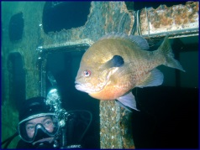
Summer
Scuba Diving - Fantasy Lake Scuba Park 3601 Quarry Road Wake Forest , NC 27587 (2 hr drive)
Camp: at the lake
Note: This could be an awesome chance to do something you don’t get to do normally.
http://www.fantasyscubapark.com/about_us.htm

The Flying Circus Air Show & Washington DC trip 5114 Co Rd 644, Bealeton, VA 22712 (5 hour drive)
Camp: at AirShow or at Prince William Forest National park
Notes: One day at Air show then spend a day or so in DC to visit the Museum of the Bible –
Blue line Metro into DC Franconia-Springfield Station
6880 Frontier Dr, Springfield, VA 22150 https://www.flyingcircusairshow.com/
https://www.nps.gov/prwi/planyourvisit/permitsandreservations.htm

Adventurer CAMP GLORIETA, in Glorieta, New Mexico (24 hour drive) JUNE 2018 https://glorieta.org/wilderness/trail-life.php Note: This is best deal out there for possible high adventure like BSA Philmont Scout Ranch http://www.traillifeusa.com/blog/55-Camp-Glorieta--Trail-Life-USA-Summer-Adventure/10/ Pecos Wilderness Backpacking, Utah Canyoneering, South Pecos Paddling Expedition https://www.youtube.com/watch?v=I7o2fjRZwho&feature=youtu.be
https://www.youtube.com/watch?v=yw2NNsAnzWQ&feature=youtu.be

Backpacking Pecos Wilderness = Backpacking the high elevations of New Mexico the lowest elevation is 8917 feet we will summit the Truchas Peak at 13,108 feet. This should top any back packing trip Troop 942 could do. OPTION = Could do half day Rio Grande whitewater Race Course section we do a lot https://www.americanwhitewater.org/content/River/detail/id/1228/ or full day Taos Box section https://www.youtube.com/watch?v=zxaOzmCZ7ms
https://www.americanwhitewater.org/content/River/detail/id/1227/ before or after we do the backing packing trip. OPTION = Down Hill Mountain Biking is pretty amazing. https://www.youtube.com/watch?v=itDKsoBtxDc https://www.mtbproject.com/directory/8017420/glorieta
Price: Begins at $70 per person per day. Includes Guides, Gear, Food, Activities https://caltopo.com/m/032D https://www.youtube.com/watch?v=tKW3NidfmuU
Utah Canyoneering = Slot Canyons are one of the most amazing places to visit in the US. Utah has many amazing slot canyons which are giant rock channels and kinds of caves. We will go through a desert and drop into these canyons. Dropping means rappelling down ropes into the canyons. Glen Canyon National Recreation Area Hite Utah. http://www.americansouthwest.net/slot_canyons/north_wash/canyons.html
Price: Begins at $90 per person per day depending on number of people https://www.youtube.com/watch?v=hH584yG0oHI https://www.youtube.com/watch?v=pGj9LD665IU
South Pecos River = This is a 60 mile rafting trip through cathedral- like canyons and boulders as big as buildings. We will camp 5 times right on the river. We will start in Texas doing 1 to 3 class rapids and take near the Rio Grande.
Price: Begins at $90 per person per day depending on number of people https://caltopo.com/m/6846
Glorieta Loop = Multisport Adventures - Another great option is to combine a lot of the trips into one Northern New Mexico adventure. We do this trip with groups a lot and it's a great way to get in a lot of adventure and variety. Days can include Summiting a Peak about tree line, Rock Climbing and Rappelling, Whitewater, Fly Fishing, Mountain Biking, Glorieta Camp's Activities, and more. This would limit extra travel and still include nights camped out. Or even nights on trail in route to the summit.Price: Begins at $70 per person per day. Includes Guides, Gear, Food, Activities https://caltopo.com/m/7M11#
All other New Mexico Trips = We commonly put together trips that involve multiple day excursions like a one day peak summit, rock climbing, fly fishing, mountain biking, canyoneering in New Mexico, whitewater rafting, and activities at Glorieta. These trips are customized and built on a group by group basis depending on age, ability, and interest.
Scott Chapman Director of Wilderness Programs www.glorieta.org/wilderness (505) 639-9717
Maximum crew size is 8 youth + 2 Registered Leaders + 2 Glorietta staff = 12
We can schedule up to 2 crews but they must be doing 2 different adventures.
We can allow rising 9th graders to go on spots that are not claimed by current HS aged Adventurers.
Travel across country takes a significant amount of time away from the activity. If the crew can afford it ($350 - $500), Albuquerque International Sunport or Santa Fe Municipal Airport. Cheaper fares if booked before Christmas.

OLD SCHOOL “Outdoor leadership + Discipleship School” Christian High Adventurer Outfitter Snowbird Wilderness Outfitters 75 Mae Johnson Way Andrews, NC 828.321.2210 http://www.swoutfitters.com/wilderness-semester/ This looks like great opportunity to do some pretty neat high adventure in the NC Wilderness without a ton of traveling and cost. Might be great place…

Screaming Eagle Outfitters http://screamineagleoutfitters.com/backpacking 340 Frankie Lane Flat Rock, NC 28731. Another Great Smokies Mountains trip outfitter 340 Frankie Lane, Flat Rock, NC 28731

Help for Shooting sports trail badges https://teamctonc.wildapricot.org/piedmont

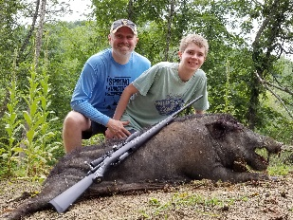
West Virginia Allegheny Mountain & Wild Boar hunting Adventure =
Base camp http://www.cooksoldmill.com/ or https://wvstateparks.com/park/moncove-lake-state-park/ -
Day one = Appalachian Trail/Groundhog access – (Cherokee Flats Day Use Area, 4920 Big Stony Creek Rd, Ripplemead, VA 24150 to Groundhog Trail, Peterstown, WV 24963) 9 miles.
https://www.alltrails.com/explore/recording/groundhog-trail-leads-to-appalachian-trail--2
Day two = Allegheny trail - Hanging Rock observatory / Peters mountain
http://www.hangingrocktower.org/
https://www.wvscenictrails.org/section-4/
Day three = Organ Wild Cave tour, -
http://www.organcave.com/
Day four = Wild Boar Hunting at Mountain Meadow hunting preserve.
http://www.mountainmeadowhunting.com/
On way home eat at Wohlfahrt Haus Dinner Theatre 170 Malin Dr, Wytheville, VA 24382
Other info: http://www.travelmonroe.com/adventure.html

SERVICE CAMPS:
Youth for Christ “Project Serve” https://camp.yfc.net/project_serve/
World Changers https://worldchangers.lifeway.com/
Ywam https://www.ywam.org/get-involved-2/outreach-trips/
Young Life https://expeditions.younglife.org/Pages/default.aspx

Adventure CAMPS:
https://camp.younglife.org/Pages/Adventure-Camps.aspx
https://rmrbackcountry.younglife.org/Pages/Adventures-Mountain-Trips.aspx
https://www.wildernesstrek.org/
https://srom.org/courses/
https://sites.google.com/view/shaccamp/home
https://www.recadventureministries.com/
https://youthchallenge.us/ministries/outdoor-adventures/
http://peak7.org/
http://newwildernessadventures.com/
https://wildernessministry.org/about/missionvisionvalues/

