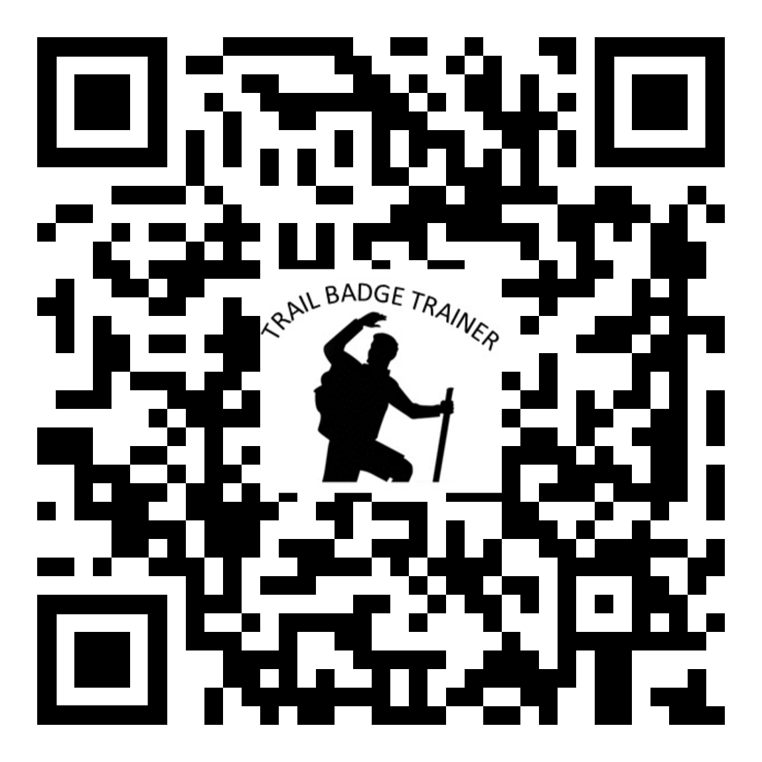

https://forms.gle/qtGLL9ntrgoKGGcH7

Trail Badge Trainer plan (Rule of Three Principle)
PATROL NAME
TRAIL BADGE NAME
TRAIL BADGE TRAINING DATE
TRAIL BADGE TRAINER NAME(S)
TRAIL BADGE MENTOR
OPENING QUESTION
INTRODUCE - TELL WHAT - RULE 1 - PICK THREE REQUIREMENTS
HANDS ON - TELL SHOW - RULE 2 -TEAM METHOD
Requirement One = "T"eam method= TELL
Requirement One = t"E"am method = EXHIBIT
Requirement One = te"A"m method = ASSIST
Requirement One = tea"M" method = MEASURE
Requirement Two = "T"eam method = TELL
Requirement Two = t"E"am method = EXHIBIT
Requirement Two = te"A"m method = ASSIST
Requirement Two = tea"M" method = MEASURE
Requirement Three = "T"eam method = TELL
Requirement Three = t"E"am method = EXHIBIT
Requirement Three = te"A"m method = ASSIST
Requirement Three = tea"M" method = MEASURE
SUMMERIZE = Rule 3 - Then TELL them WHAT YOU just TOLD them (5 minutes)

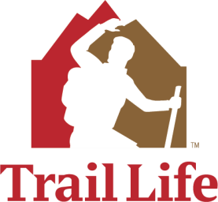
Camping
Outdoor Skills Frontier

Name

Do all of the following requirements (1-8)

1. Explain how the low-impact camping method (See The Trailman’s Handbook) helps fulfill the
Trailman Oath to “be a good steward of creation.”
2. Research if people camped in the Bible.
a. Did they use tents?
b. Did they build fires?
3. Given the advancements in technology and housing, what makes camping so special, different, and fun for young people and families?
4. Explain what you experience when you camp in the outdoors that makes you think about God.
5. With your Troop, Unit, Patrol or another group of youth, complete the following activities:
a. At a camping area, explain where the best place to pitch a tent would be and why.
b. With a buddy or by yourself, correctly pitch a tent.
c. Take the tent down, correctly fold it, and pack it away.
d. Explain the proper care for tents.
e. Correctly pitch a dining fly, tarp, or other type of covering.
6. Camping equipment
a. Make a list of personal equipment you should pack on a weekend camping trip for hot, cold, and rainy weather.
b. Demonstrate on a camping trip that you have packed all your equipment from your list.
7. Wilderness sanitation
a. Demonstrate digging and covering a proper cat hole for backwoods human excrement disposal using a small or backpacking shovel.
b. Explain proper disposal methods for toilet paper for your local wilderness area(s).
8. Spend at least 15 nights camping in a tent or under the stars and participate in assigned cooking, cleanup, and other camping related duties. (Log your camping trips in The Trailman’s Handbook)

First Aid
Life Skills Frontier

Name

Do requirement 1
1. Participate in a discussion with your patrol, Troop, family, or another group about the following:
a. Read Genesis 1:26-27. What do these scriptures tell us about why we as a society spend so many resources (time, effort, and money) to protect people’s health and safety using first aid and other emergency care?
b. Do we expend the same amount of resources on similar animal care?
c. What biblical truth explains those answers?
2. Cardiopulmonary Resuscitation (CPR), Automated External Defibrillator (AED) Use, and Choking First Aid: Choose either requirement 2a or 2b
a. Certification
i. Complete a CPR-AED certification class taught by the American Heart Association or American Red Cross, or Emergency Care and Safety institute that includes skill practice with CPR dummies and a teaching AED and teaches these three skill sets:
- Adult CPR, AED, and choking,
- Child CPR, AED, and choking, and
- Infant CPR and choking.
ii. Find out if your meeting location has an AED and be aware of where it is located.
b. Self-study
i. Explain hands-only CPR.
ii. Stopped breathing.
iii. Explain the use of an AED.
iv. Find out if your meeting location has an AED and where it is located.
v. Describe and show how to tell if someone is choking and when intervention is required.
vi. Describe and show the positions for treating choking in an adult, pregnant woman, child, and infant.

Basic First Aid: Do either requirement 3 or requirements 4
3. Complete a Basic First Aid certification class taught by the American Heart Association, American Red Cross, or Emergency Care and Safety Institute that includes a hands-on skills section.
4. Self-study Option: Basic First Aid
a. Demonstrate the following first aid action plan basics:
i. Checking the scene
ii. Calling for help (911 or Poison Control)
iii. Approaching safely
iv. Providing urgent treatment
v. Treating for shock
vi. Deciding the next steps
b. Demonstrate the following rescuer safety precautions:
i. Wearing of eye protection, breathing mask, and vinyl gloves
ii. Proper glove removal
iii. Proper handwashing
c. Explain the symptoms and first aid for the following sudden illness emergencies:
i. Heart Attack
ii. Fainting
iii. Low blood sugar
iv. Stroke
v. Seizure
vi. Shock
vii. Poisoning
d. Explain and demonstrate the first aid response for the following:
i. Severe bleeding on a leg and arm
ii. Nosebleed
iii. Head, neck, and spine injuries
iv. Broken bones, including splinting
e. Explain the first aid response for the following injuries:
i. Severe bleeding you cannot stop with direct pressure
ii. Bleeding from mouth
iii. Tooth injuries
iv. Eye injuries
v. Penetrating and puncturing objects
vi. Internal bleeding
vii. Burns (first, second, and third degree)
viii. Electric shock injuries
f. Explain the first aid for the following bites and stings:
i. Animal and human bites
ii. Snakebites
iii. Insect, bee, and spider bites and stings
iv. Poisonous spider, and scorpion bites and stings
v. Ticks
g. Explain the first aid for the following temperature-related emergencies:
i. Heat cramps
ii. Heat exhaustion
iii. Heatstroke
iv. Frostbite
v. Hypothermia

Trail Life USA First Aid Addendum: Do requirements 5 through 12
5. Explain and demonstrate first aid for the common outdoor injuries listed below:
a. Cuts and scrapes
b. Splinters
c. Blisters
d. Something in your eye
e. Sunburn
f. Poisonous plants
g. Dehydration
6. Explain how the following methods help prevent common outdoor injuries and emergencies:
a. Work gloves, mole skin, adhesive tape (splinters and blisters)
b. Sunscreen, sunglasses, broad-brimmed hats
c. Long pants and long-sleeved shirts

d. Insect repellent
e. Plenty of water and a water filter
f. Synthetic insulating layers and nylon/Gore-Tex outer wear
g. Sturdy well-fitting hiking boots/shoes
7. Explain why sun protection is especially important while on the water, in the snow, or at high altitude.
8. Make first aid kits yourself:
a. Make a personal first aid kit for hiking and other wilderness trips.
b. Make a home first aid kit for your family.
9. Explain how to get medical assistance while on a wilderness camping trip, river trip, and on open water.
10. Demonstrate splinting, slings, and bandaging for the following injuries to permit transport of victims:
a. Twisted ankle (sprain or strain)
b. Broken ankle
c. Broken lower arm
d. Broken upper arm
e. Broken collarbone
f. Broken lower leg
g. Broken upper leg
11. Demonstrate the following methods of transporting victims:
a. Walking assists: one and two rescuers
b. Drags: Blanket, Shoulder, and Ankle (conduct these with great care)
c. Two-rescuer Carries: Two-hand seat, four-hand seats, and chair carry
d. Human stretcher carry for 3-6 Trailmen
e. Improvised stretchers: blanket and shirt/coat (2)
12. Demonstrate the emergency procedures for the following clothing fire emergencies:
a. Stop, Drop, and Roll response to your own clothes catching fire
b. Response to another person who panics and runs

Trail Badge Mentor Signature Date

Trail Skills
Outdoor Skills Frontier

Name

Do all of the following requirements (1-9)
1. Discuss and describe how our name “Trail Life” has both natural and spiritual meanings.
2. Explain what these scriptures teach us about the “spiritual trail” of Christian life.
a. Matthew 7:13
b. Psalms 119:105
c. Psalms 16:11
d. Proverbs 3:6
e. John 16:4
3. Trail ethics
a. Explain how the low-impact camping method (see The Trailman’s Handbook) relates
to Trail Skills and helps fulfill the Trailman Oath to “be a good steward of creation.”
b. Participate in a Hikers Code (see The Trailman’s Handbook) orientation and learn the buddy system.
4. Trail safety
a. Describe how to identify poisonous plants in your area, such as poison ivy, poison oak, poison sumac, stinging nettle, and Flowering Poodle Dog Brush (Sticky Nama).
b. Describe how to identify venomous snakes in your area such as rattlesnakes, coral snakes, or water moccasins.
c. Describe natural hazards you might encounter on a hike, including river crossings and what to do if you are faced with them.
d. Describe the importance of safe, clean water, and explain how to identify safe or unsafe water. Demonstrate at least two methods of water purification.
5. Equipment
a. Describe the clothing necessary for hiking, including proper footwear and socks.
b. Explain the limit on how much weight you should carry and how much water you should take.
c. Demonstrate proper packing and necessary items for a day pack for a day hike.
6. Navigation

Trail Life USA | Required Trail Badge – Trail Skills | 2019 | 1

a. Explain how an orienteering compass works.
b. Explain what a topographic map is and what the contour lines and map symbols mean.
c. Demonstrate how to hold an orienteering compass and take a reading.
d. With an orienteering compass, orient a map to North.
e. With an orienteering compass and a topographical map, demonstrate one method of adjusting for magnetic declination.
f. With an orienteering compass and a topographical map, demonstrate finding your location using bearings to landmarks.
7. Measurements
a. Measure the average length of your pace.
b. Using pacing and the felling method, measure the height of a building, tree, flagpole, or other feature.
c. Demonstrate course direction finding in daylight or moonlight without a compass or GPS receiver.
8. Do one of the following options:
a. Complete an orienteering course of at least 1 mile and 5 stations.
b. Complete a compass course of at least one mile and 8 bearings.
9. Using a map and compass together, take a five-mile hike with your patrol or Troop.

Trail Badge Mentor Signature Date

Our Flag
Heritage Frontier

Name

Do all of the following requirements (1-9)
1. Describe how and why we respect the American flag.
2. How is respecting the flag related to “respect authority” in the Trailman Oath?
3. Basic flag ceremonies:
a. Demonstrate folding the American flag. (See The Trailman’s Handbook)
b. Demonstrate the proper placement of hands (and hats) while reciting the Pledge of Allegiance.
c. Demonstrate displaying the colors for an outdoor flag ceremony.
d. Demonstrate raising and lowering the American flag for an outdoor flag ceremony.
e. Participate in a flag ceremony for your Troop meeting, award ceremony, or other indoor ceremony.
4. Know the Flag Code and its history. Diagram the proper way to display the American Flag in the following circumstances.
a. When carried in a procession with another flag or flags
b. When displayed with another flag against a wall with crossed staffs
c. When a number of flags on staffs are displayed with the American Flag
d. When state flags or other pennants are flown from the same halyard with the American flag
e. When flags of two or more nations are displayed
f. When a flag is displayed on a staff projecting horizontally from a windowsill or building
g. When the flag is not on a staff and is displayed flat against a wall horizontally and vertically
h. When used on a speaker's platform
i. When flown at half-staff
j. When used to cover a casket
5. Make a diagram of the American flag and flagpole, labeling all its parts. Include and be able to define the hoist, peak, fly, staff, halyard, and union.

Trail Life USA | Required Trail Badge – Our Flag | 2 01 9 | 1

6. Learn the history of the Pledge of Allegiance.
7. Learn the date, the conflict, the American flag's design, its physical condition, and the situation that prompted Francis Scott Key to write the Star Spangled Banner.
8. Read through the words of the National Anthem written by Francis Scott Key. Explain line by line in your own words what was going on and his views on it.
9. Do 3 of the following activities:
a. Participate in the color guard for a flag ceremony for a community event.
b. Participate in the color guard for an outdoor flag ceremony.
c. Find a script giving a meaning or symbolism to each of the 13 folds required to properly fold an American Flag and use it in a flag ceremony.
d. Find or write a special flag ceremony and perform it in front of an audience.
e. Teach a Woodlands patrol a flag ceremony and help them perform it at a Troop function.
f. Find or write a respectful American flag retirement ceremony and perform it at a campfire program.
g. Participate in a flag planting service project at a cemetery for their Memorial Day service honoring veterans.
h. Learn the history and usage of the 21 Gun Salute.
i. Research the origins of Flag Day and plan a special event celebrating the day for your Troop or community.

Trail Badge Mentor Signature Date

Ropework
Outdoor Skills Frontier

Name

Do all of the following requirements (1-4)
1. Explain how the low-impact camping method (See The Trailman’s Handbook) relates to ropework and helps fulfill the Trailman Oath to “be a good steward of creation.”
2. Whipping and fusing
a. Demonstrate whipping the ends of a natural fiber rope.
b. Demonstrate fusing the ends of a synthetic rope.
3. Tie the following knots and describe their usefulness:
a. square knot
b. bowline
c. two half-hitches
d. taut line hitch
e. clove hitch
f. timber hitch
4. Lashing
a. Tie the following lashings and describe their function:
i. Square
ii. Diagonal
iii. Shear
iv. Tripod
v. Round
vi. Floor
b. Lash the following trestles:
i. X-Trestle
ii. A-Trestle
iii. H-Trestle.
c. Make a useful structure for camp using at least three different types of lashings.

Trail Life USA | Required Trail Badge – Ropework | 20 1 9 |

Fire Ranger
Outdoor Skills Frontier

Name

Do all of the following requirements (1-6)

1. Explain how the low-impact camping method (See The Trailman’s Handbook) relates to fires and helps fulfill the Trailman Oath to “be a good steward of creation.”
2. Research what the Bible says about fire.
a. List at least three instances of fire in the Bible.
b. How is fire a curse and a blessing to mankind?
c. Read Exodus 3:2, Judges 13:20, Hebrews 12:29, Acts 2:3-4. How does God use fire to describe his presence, passion, and purity in the Bible?
3. How did man’s ability to start, sustain, and control fire change the world?
4. Fire safety
a. Explain the use of buckets, rakes, and shovels in containing a campfire in a certain location.
b. Describe safe places to have a campfire, how to learn local regulations, and how to set up a fire circle.
c. Describe safe vs. unsafe clothing near campfires and open flames.
d. Describe safe vs. unsafe behavior around a campfire.
e. Demonstrate how to put out fire on your clothing, hair, or body.
f. Demonstrate safe striking of stick and book matches and safe use of a lighter.
5. Fire materials
a. Explain the use and purpose of tinder, kindling, and fuel firewood.
b. Explain why wet, green, or ant/vine-covered wood is unsafe and not good for fires.
c. Describe several types of fire starters that can be made or purchased.
6. Fire building
a. Demonstrate building at least three different fire-lays and explain when you would use each one.
b. Light one of the fire lays, attend it, and keep it burning.
c. When finished with the fire, demonstrate the proper way to extinguish it to dead out.

Aquatics
Outdoor Skills Frontier

Name

Do all of the following requirements (1-9)
1. Research what the Bible says about water.
a. Describe water in the creation process.
b. How was it used as a curse and a blessing?
c. Where did all the water in the world come from? If there ever was a time where nothing existed, how could all the water come from nothing?
d. List the ways in which water sustains life on earth.
e. List the ways that natural bodies of water (oceans, lakes, springs, & rivers) are a gift
to man for food, travel, and recreation to enjoy God’s creation.
2. Participate in a Safe Aquatics method orientation and fulfill the following requirements pursuant to the Safe Aquatics method. (See The Trailman’s Handbook)
3. Complete the Swimming Competency Test at the Swimmer level. (See The Trailman’s
Handbook)
4. Demonstrate how to properly put on a personal flotation device (PFD) and while wearing the PFD do the following:
a. Jump feet first into deep water and swim 25 yards.
b. Learn and demonstrate the heat escape lessening posture (HELP) cold-water survival technique.
c. With a group, learn and demonstrate the Huddle cold-water survival technique.
5. Demonstrate the following reach and throw rescues:
a. Several reach assists including arm, leg, and towel reaches without entering the water, and pole or shepherd's crook assists
b. Throwing a rescue tube or ring buoy to someone at least 25 feet out in the water
6. After ensuring the safety of the swimming area, in deep water, do the following::
a. Tread water for 3 minutes.
b. Survival float on your stomach for 3 minutes.
c. Float on your back for 2 minutes.
d. Demonstrate a feet-first surface dive.
e. Demonstrate a head-first surface dive, and recover a diving ring or some other object from the pool bottom.
7. While wearing shoes, long pants, and a long-sleeve shirt over your swimsuit, jump into deep water.
a. While treading water, remove the shoes and pants.
b. Inflate your shirt and float long enough to prepare your pants.
c. Inflate your pants and use them to float for one minute.
8. Demonstrate that you can continuously swim 200 yards without stopping to rest.
a. Use at least three of the following five strokes: front crawl, backstroke, sidestroke, breaststroke, and elementary backstroke.
b. Swim each of the three selected strokes for at least 50 yards.
9. Participate in a skill orientation and an open activity for three of the following aquatics activities: Group water game, swim race, diving, snorkeling, Red Cross Junior Lifeguard, scuba, stand-up paddle boarding, boardsailing, canoeing, kayaking, rowing, sailing, peddle boats, water skiing, wake boarding, or an alternate water activity approved by your unit leader.

Trail Badge Mentor Signature Date

Outdoor Cooking
Outdoor Skills Frontier

Name

Do all of the following requirements (1-9)
1. Explain how the low-impact camping method (See The Trailman’s Handbook) relates to outdoor cooking and helps fulfill the Trailman Oath to “be a good steward of creation.”
2. Demonstrate the following:
a. Sanitation practices
b. Washing dishes
c. Personal hygiene
d. Food Storage
e. Protecting your food from animals
3. Explain the advantages, disadvantages, and safety issues involved in using propane/butane camp stoves, liquid fuel stoves, lightweight stoves, wood fires, and charcoal.
4. Set-up, light, and use a lightweight camp stove.
5. Cook a one-pot meal over the fire or camp stove.
6. Cook a foil meal on charcoal.
7. Plan or help plan a balanced nutritious menu for a weekend camping trip.
8. Purchase the food items needed for a weekend camping trip within the budget set by your leader.
9. With a buddy or by yourself, prepare, cook, and clean up the planned meals using any of the following means: Campfire, propane stove, liquid fuel stove, charcoal, Dutch oven, sandwich irons, box oven, or solar cooker/oven.

Trail Badge Mentor Signature Date

Woods Tools
Outdoor Skills Frontier

Name

Do all of the following requirements (1-8)
1. Explain how the low-impact camping method (See The Trailman’s Handbook) relates to Woods Tools and helps fulfill the Trailman Oath to “be a good steward of creation.”
2. Describe how knives, swords, and axes were used in history as weapons and tools.
3. Give at least 5 Biblical references to knives, swords, and axes.
4. Describe the Woods Tools Safety Rules (See The Trailman’s Handbook).
5. Demonstrate how to clean and sharpen a pocketknife.
6. Demonstrate how to clean, stow/cover, and change a saw blade for either a folding or bow saw.
7. Demonstrate cleaning and sharpening an ax or hatchet.
8. Following the Woods Tools Safety Rules, participate in skill instruction as needed and do three of the following using a knife, bow saw, folding saw, hatchet, or ax:
a. Whittle a cooking stick and cook a food item over a wood or charcoal fire.
b. Whittle something out of soft wood.
c. Make a fuzz stick.
d. Prepare tinder, kindling, and fuel wood for a small fire.
e. Saw off a piece of a log at least 2-inches in diameter.
f. Chop through a log at least 2-inches in diameter on a chopping block.
g. Split a log.
h. Limb a log (stand on the opposite side of the log from where you are limbing).
i. Use an ax to cut a V-shaped notch at least 2-inches deep in a large log (bucking).

Trail Badge Mentor Signature Date

